Year 9 |  | Enlargement & Similarity | Non Calculator
Skills and Knowledge Assessed:  - Use the enlargement transformation to explain similarity and develop the conditions for triangles to be similar (ACMMG220)  - Solve problems using ratio and scale factors in similar figures (ACMMG221) |  |  | Name_________________
Section 1 Short Answer Section
Write all working and answers in the spaces provided on this test paper.
YOU WILL NEED A RULER.
An equilateral triangle has sides which are 5 cm long. An enlargement of this triangle is drawn, with an enlargement factor of 4.
Describe the sides and angles of the new shape.

……………………………………………………………………………………………....

……………………………………………………………………………………………….
Rhombus X is enlarged to produce Rhombus Y.
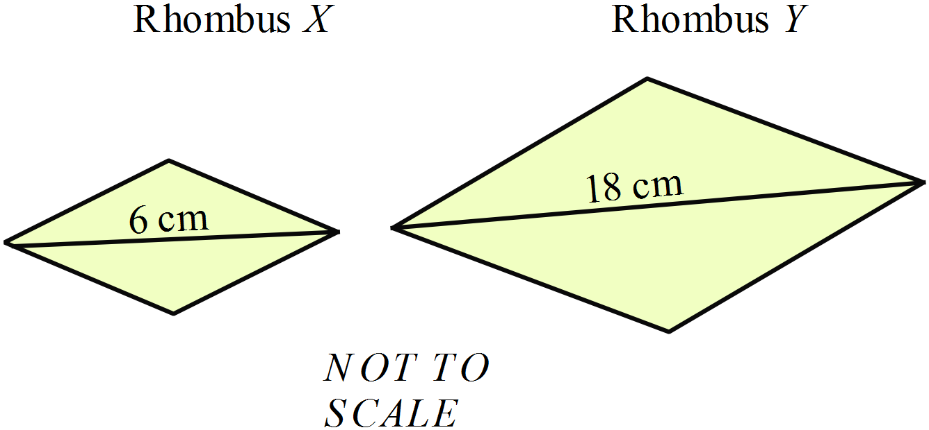

What is the enlargement factor?

…………………………………………..

…………………………………………..

…………………………………………..
An isosceles triangle A is enlarged with scale factor 3, to produce triangle B.
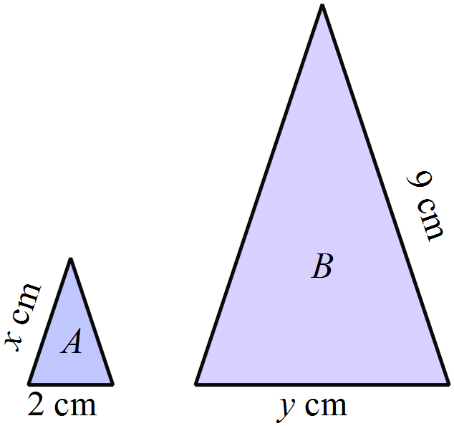What are the measurements marked x and y?

………………………………………………

……………………………………………....

………………………………………………

……………………………………………….

The polygons ABCDEFGJ and PQRSTUVW are similar.
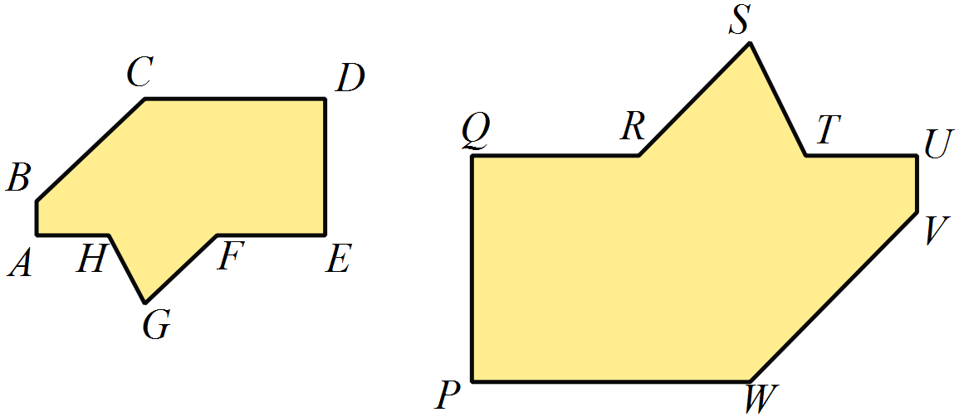Name an angle which is equal to 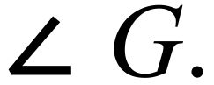

………………………………………………

……………………………………………….
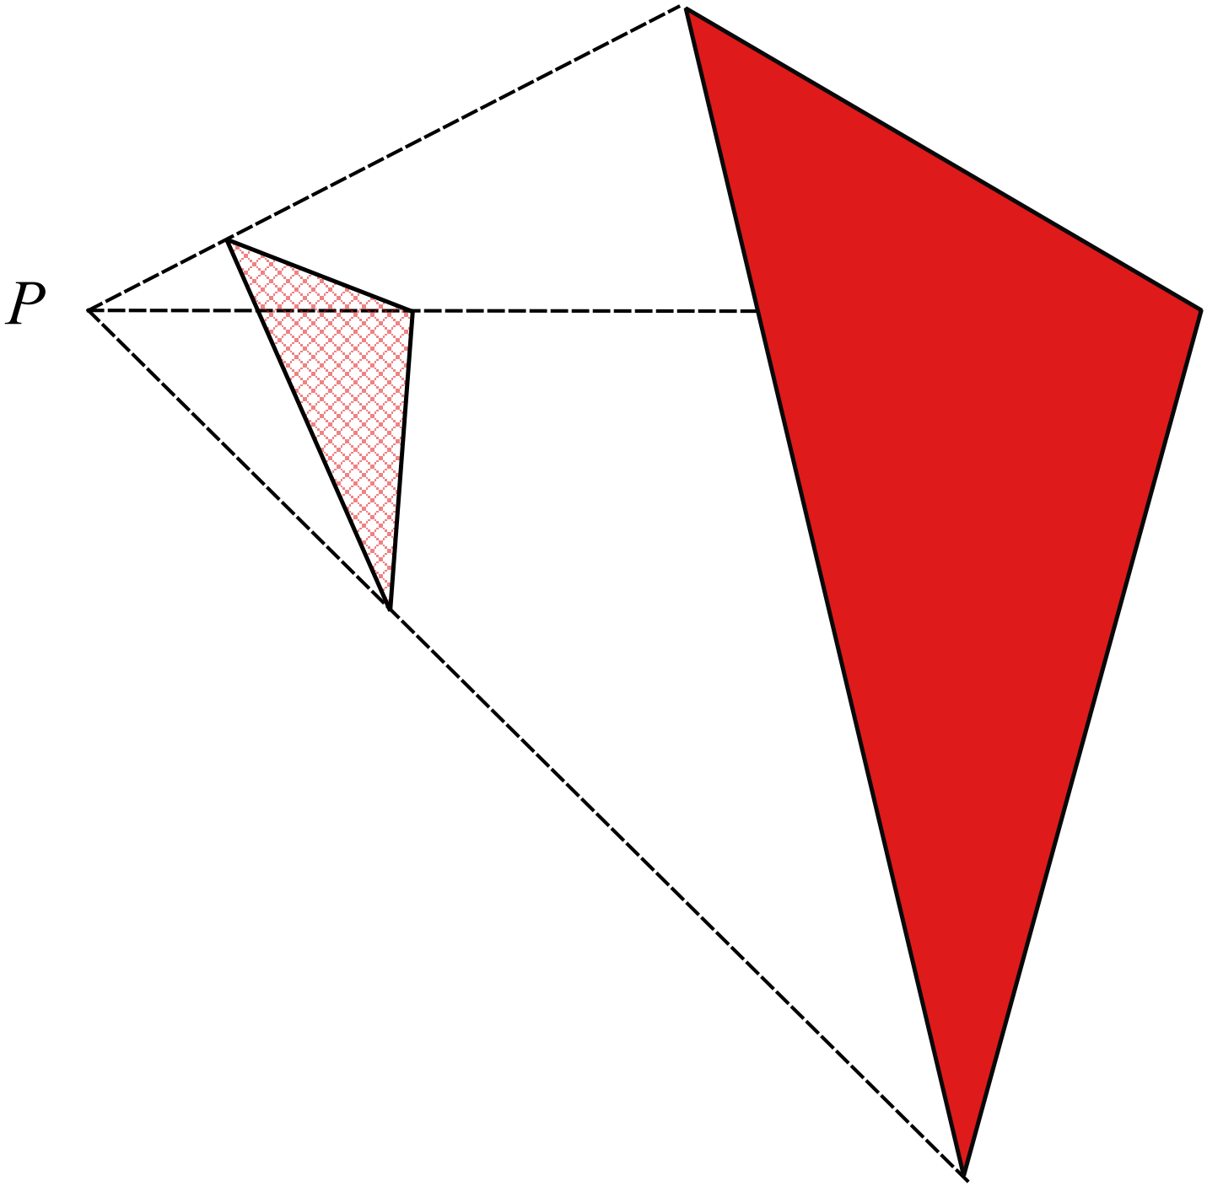By measurement and calculation, find the scale factor when the lighter triangle is enlarged to give the darker triangle.

..................................................................

..................................................................

..................................................................

..................................................................

Triangle ABC is enlarged with a scale factor of 2.5, to produce Triangle DEF.
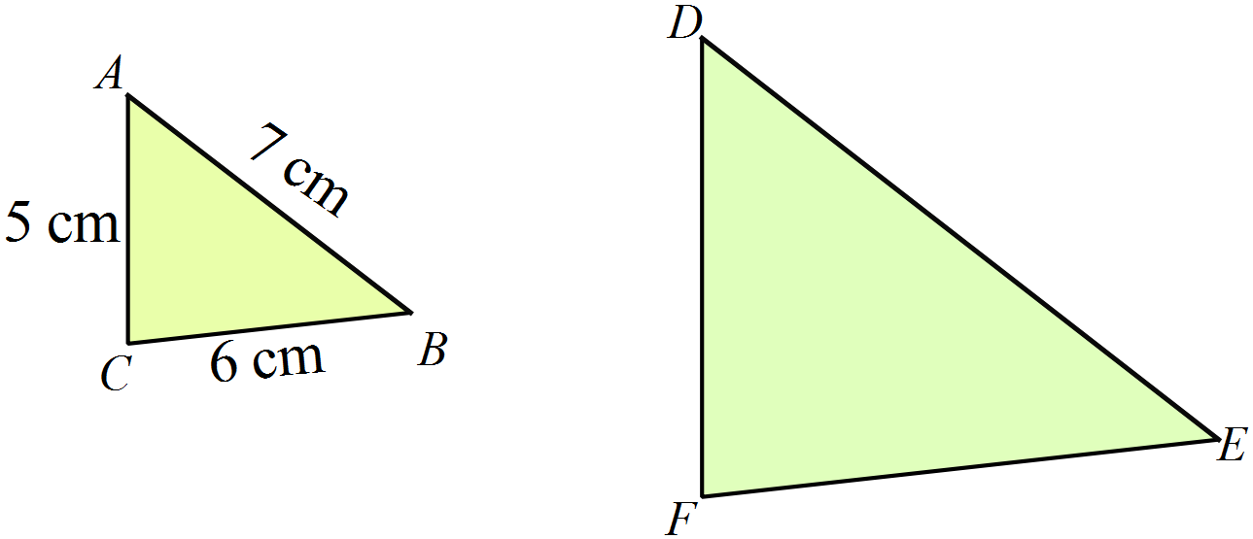What is the length of FE?

…………………………………………..

…………………………………………..

…………………………………………..
Jayden says “All squares are similar.”
Determine if he is correct and explain why.

……………………………………………………………………………………………....

……………………………………………………………………………………………....

……………………………………………………………………………………………….
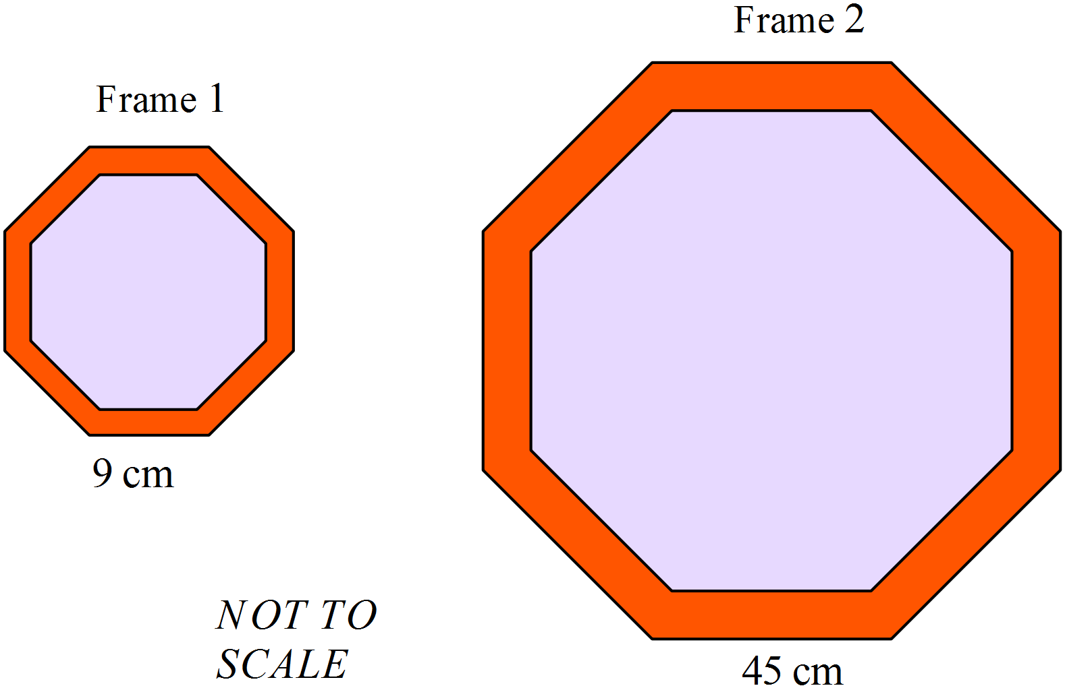The two photo frames are both in the shape of regular octagons.
A photo which measures 20 cm square can be cropped neatly into the smaller frame.
What size photo would be needed for the larger frame?

………………………………………………

……………………………………………....

………………………………………………

……………………………………………….
Dustin is drawing an enlargement of the quadrilateral UVWX with scale factor 3 from the point P.
He has marked the position of the points U’ and V’.
By measurement and calculation find the position of W’ and X’ and complete the quadrilateral.
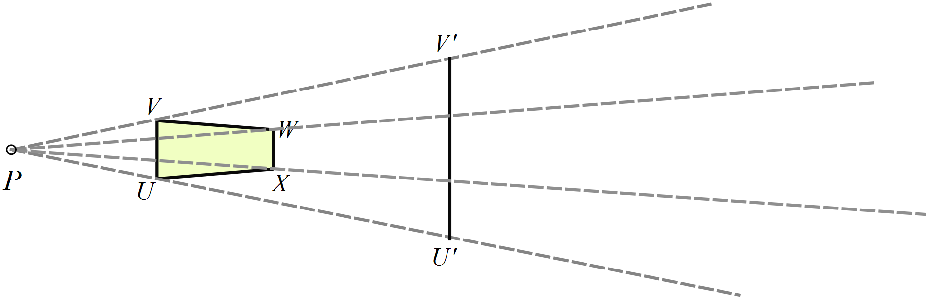

What is the length of  ?
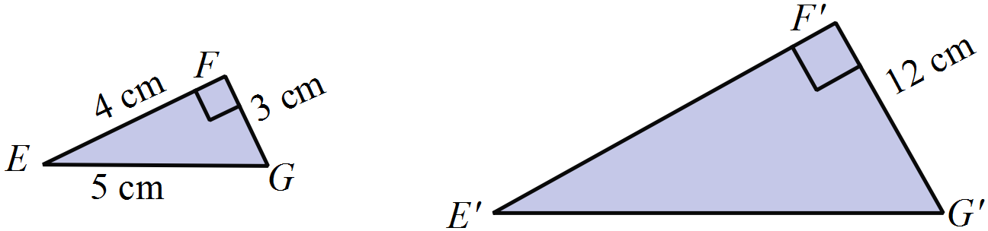
NOT TO
SCALE

……………………………………………………………………………………………....

……………………………………………………………………………………………….
By measurement and calculation find the scale factor of the enlargement.
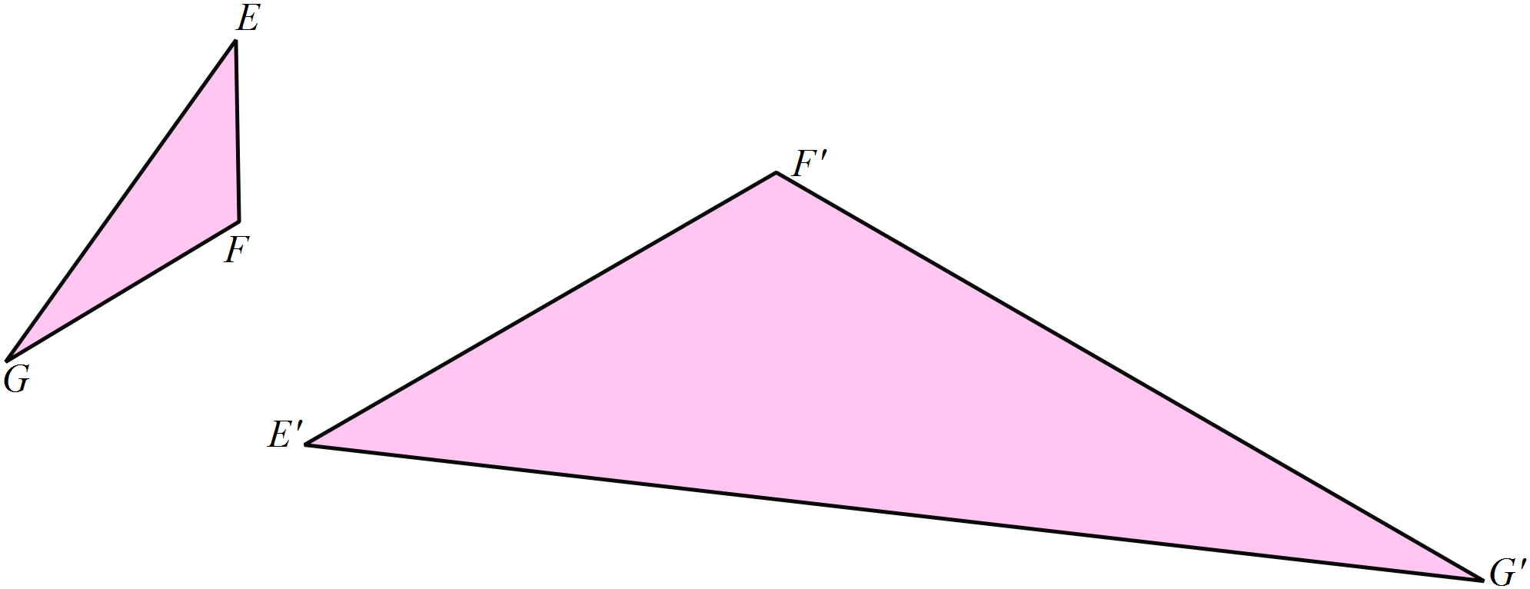

……………………………………………………………………………………………....

……………………………………………………………………………………………....

……………………………………………………………………………………………….
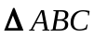 ||| 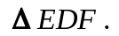
EF is the longest side of 
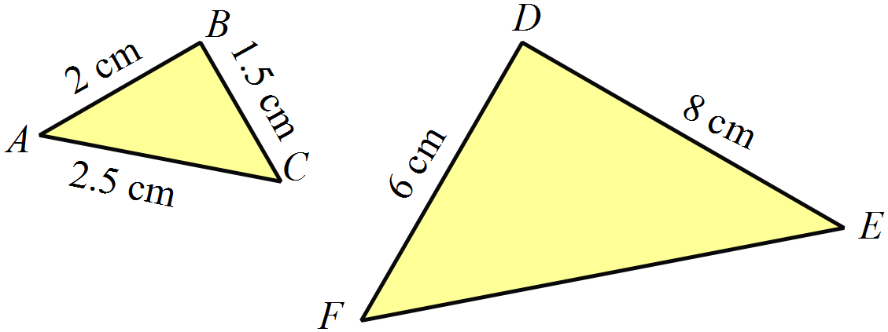What is the length of EF?

………………………………………………

……………………………………………....
NOT TO
SCALE
………………………………………………

……………………………………………….
Explain why 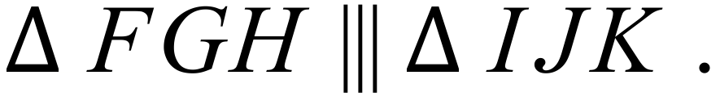
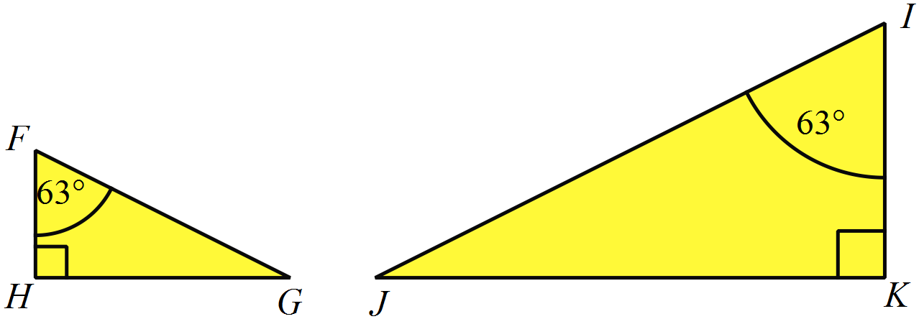
………………………………………………

……………………………………………....

………………………………………………

……………………………………………….
A 24 m high electricity pole casts a shadow.
At the same time a 1.2 m high vertical fence post casts a shadow which is 0.9 m long.
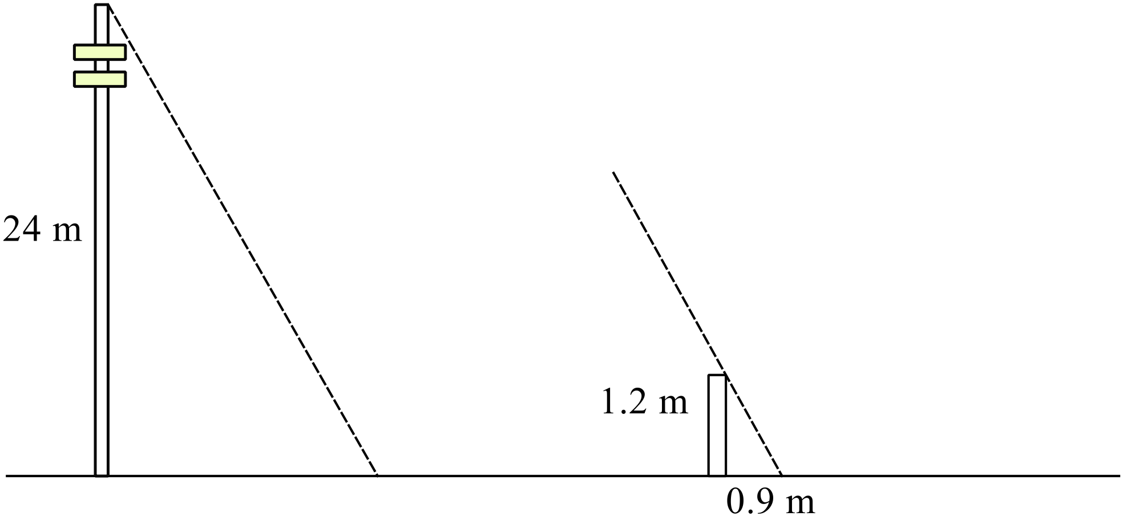Use this information to calculate the length of the shadow of the electricity pole.

NOT TO
SCALE

……………………………………………………………………………………………....

……………………………………………………………………………………………....

……………………………………………………………………………………………..
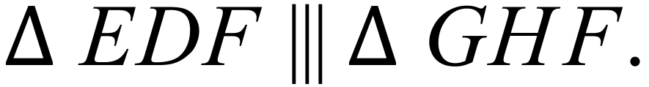
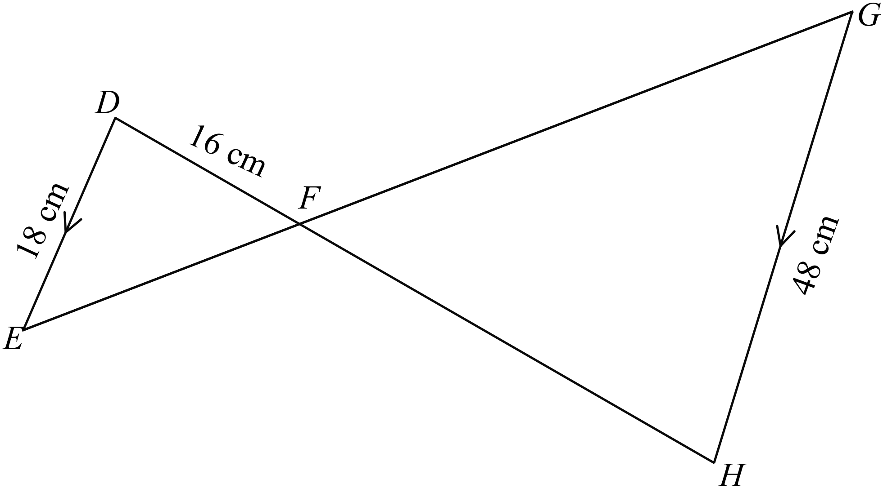Calculate the distance FH.

……………………………………………………………………………………………....

……………………………………………………………………………………………....

……………………………………………………………………………………………….

Year 9 |  | Enlargement & Similarity | Calculator Allowed
 |  | Enlargement & Similarity | Name_________________
Section 2 Multiple Choice Section
Mark all your answers on the accompanying multiple choice answer sheet, not on this test paper. You may do any working out on this test paper. Calculators are allowed for this section.
YOU WILL NEED A RULER.
The team trophy for a netball competition is triangular in shape, with the measurements shown.
The individual trophies are similar to the team trophy and are 15cm tall.
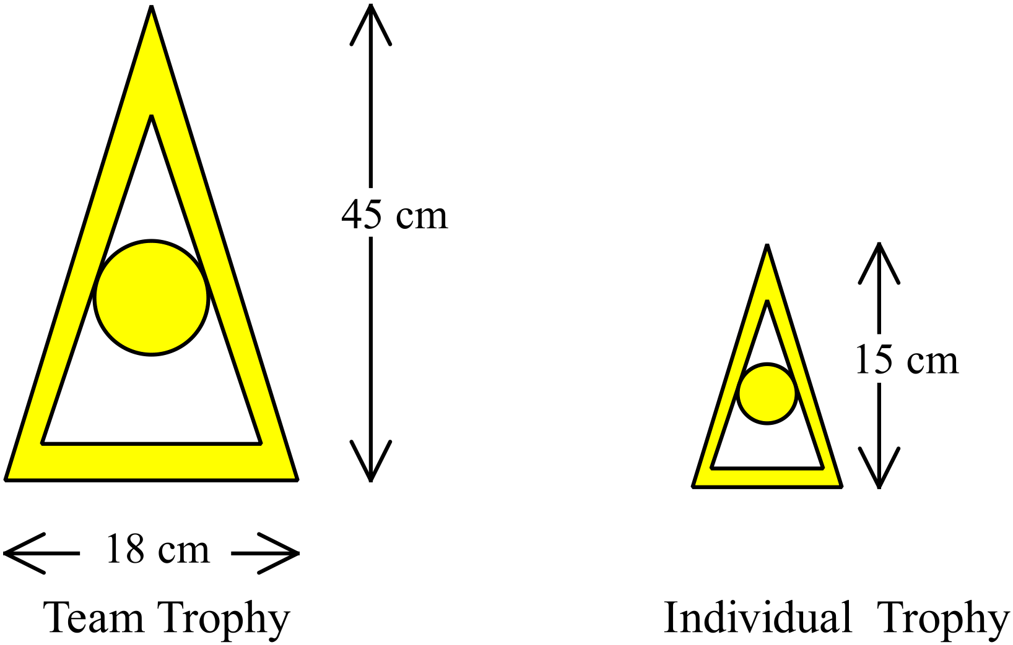

How wide is the base of the individual trophy?

A. 5 cm B. 6 cm C. 7.5 cm D. 9 cm
What scale factor would enlarge Triangle X to Triangle Y?
(All measurements are in cm).
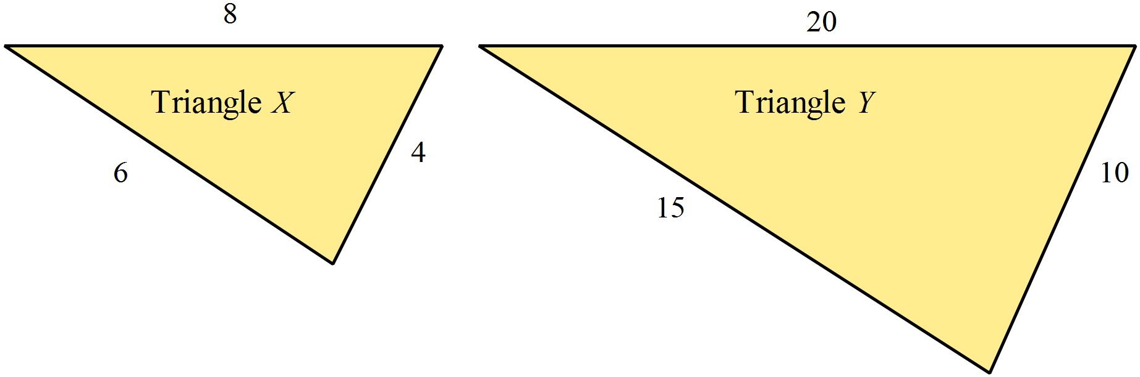

A. 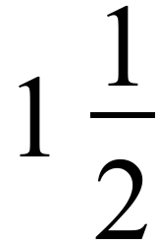 B. 2 C. 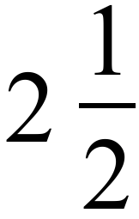 D. 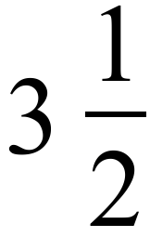
An isosceles triangle with sides 18 cm, 18 cm and 15 cm is enlarged with scale factor of 3.
What are the side lengths of the new triangle?

A. 6 cm, 6 cm and 5 cm.
B. 21 cm, 21 cm and 18 cm.
C. 36 cm, 36 cm and 30 cm.
D. 54 cm, 54 cm and 45 cm.
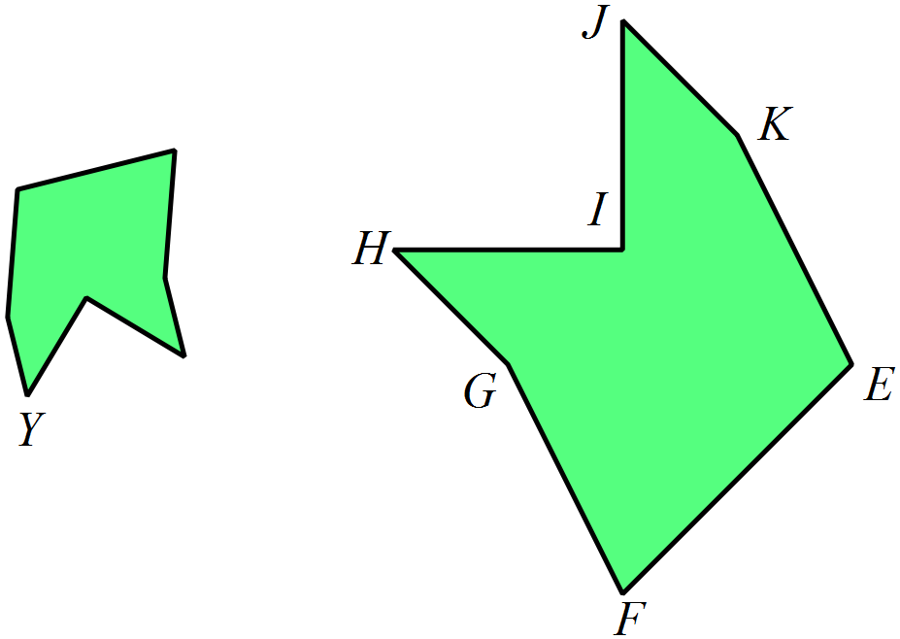Two similar polygons are shown.
Which angle in the larger polygon would be equal in size to angle Y in the smaller polygon?

A. Angle E
B. Angle F
C. Angle H
D. Angle J
Which two words (in order) complete this statement correctly?
In a pair of similar triangles the corresponding _________ are equal and the corresponding __________ are in the same ratio.

A. angles, sides
B. areas, sides
C. sides, angles
D. sides, areas

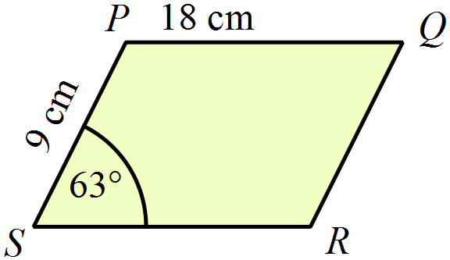Which of the four parallelograms shown below is similar to parallelogram PQRS?

NOT TO
SCALE

- 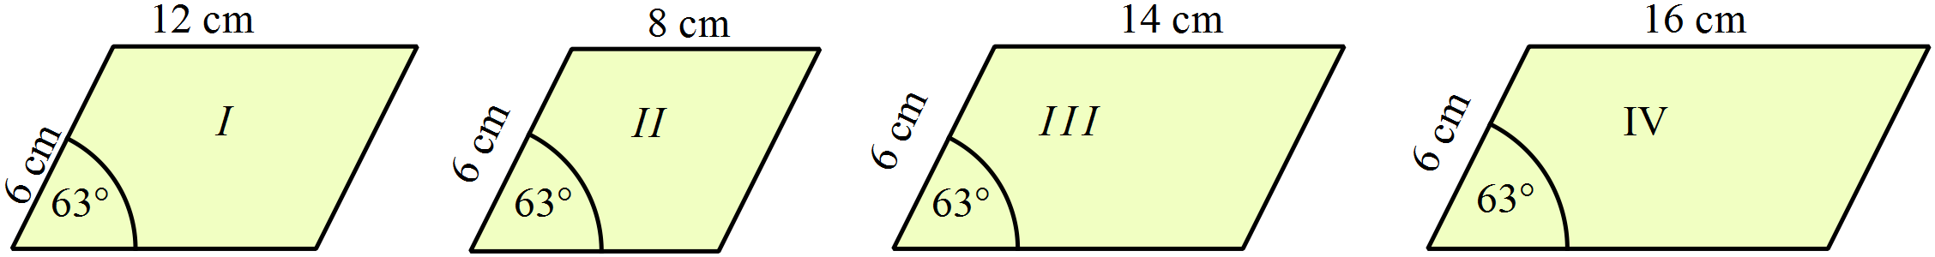 B. C. D.

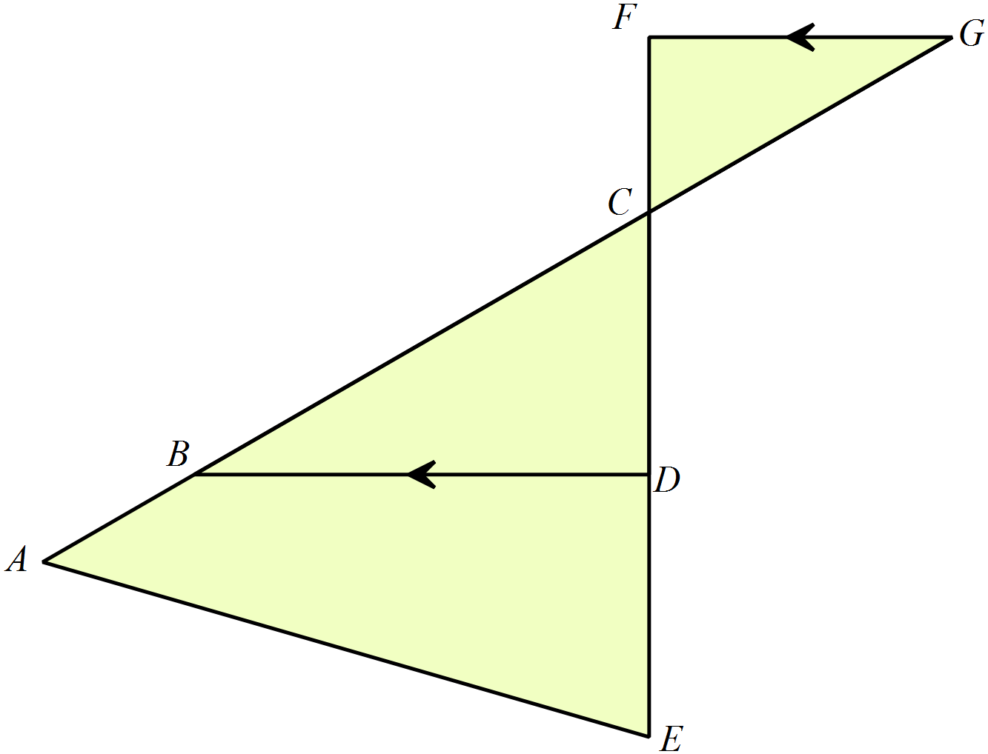Which two triangles are similar in this diagram?
NOT TO
SCALE

A. 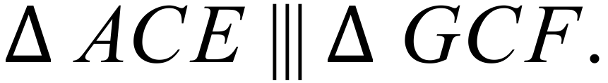
B. 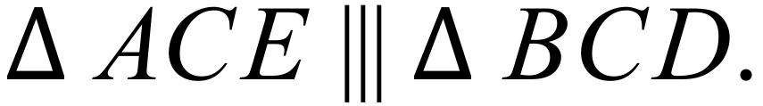
C. 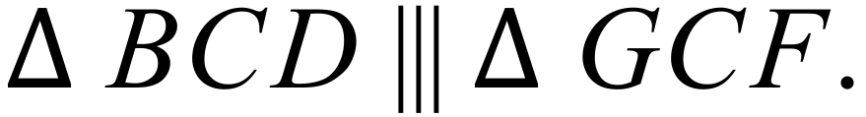
D. 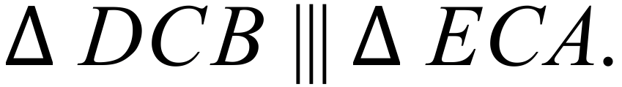

When comparing triangles, which statement is true?
A. All triangles are similar.
B. All equilateral triangles are similar.
C. All isosceles triangles are similar.
D. All scalene triangles are similar.
A set of plates are in the shape of regular hexagons with a circular insert.
They are all similar and are made in two different sizes as shown.
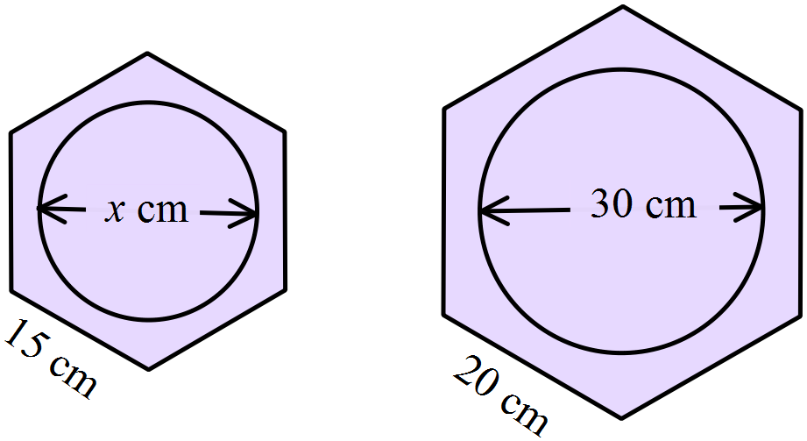
NOT TO
SCALE

What is the value of x?
A. 20 cm B. 22.5 cm C. 25 cm D. 27.5 cm
The elevation of this building is drawn to a scale of 1 : 120.
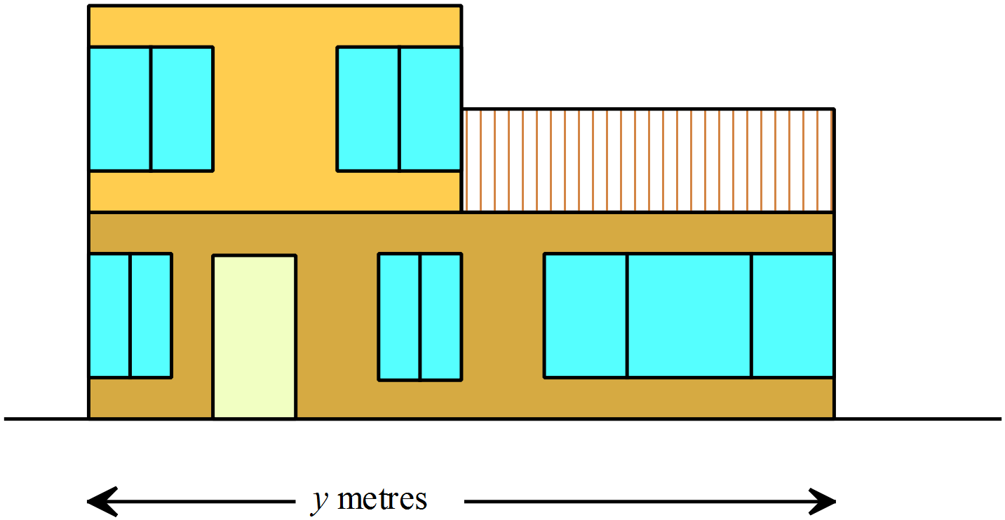

What is the width of the actual building?

A. 9.0 m B. 10.8 m C. 12.5 m D. 13.3 m
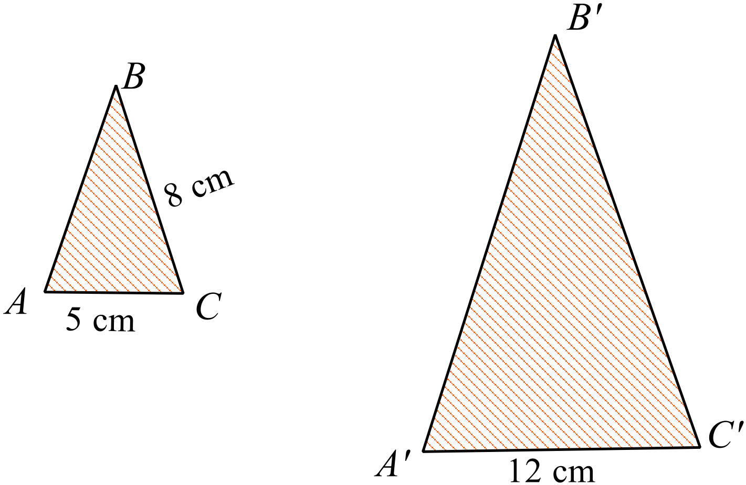  and its image under an enlargement are shown.
What is the length of B’C’?

A. 7.5 cm
B. 18.0 cm
NOT TO
SCALE
C. 19.2 cm
D. 24.0 cm

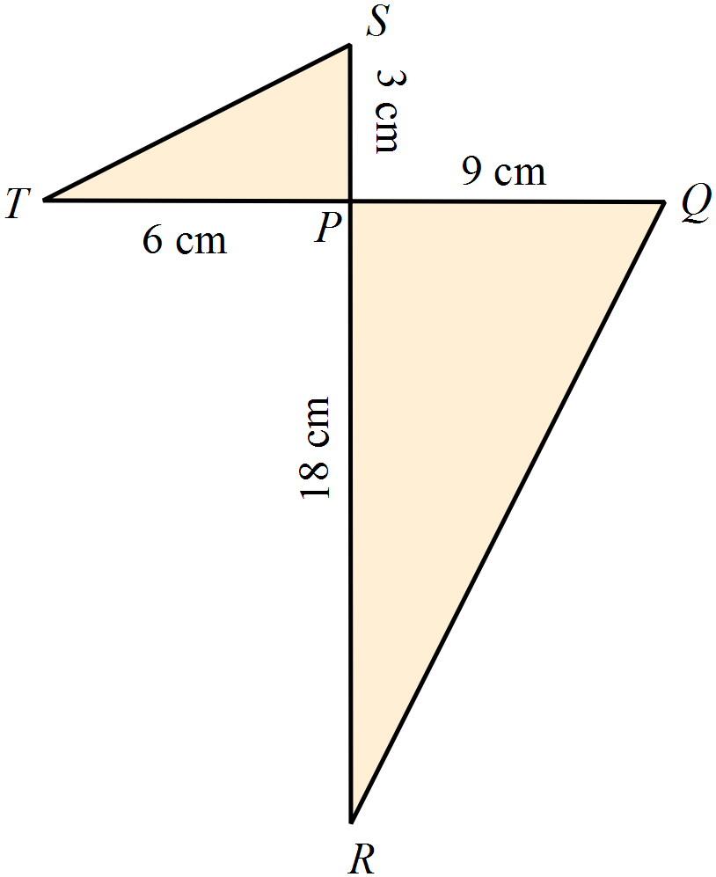Which reason could be used to prove that 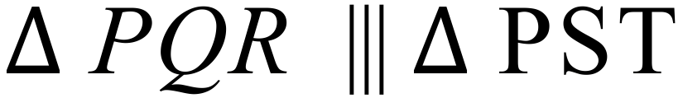 ?

NOT TO
SCALE

A. The three corresponding angles of the triangles are equal.
B. The three corresponding angles of the triangles are in proportion.
C. The three corresponding sides of the triangles are in proportion.
D. Two corresponding sides of the triangles are in proportion and the included angle is equal.
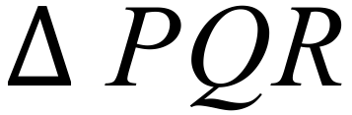 is an enlargement of 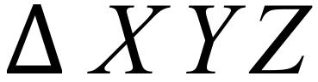.
NOT TO
SCALE
The longest side of  measures 20 cm.
What is the scale factor of the enlargement?
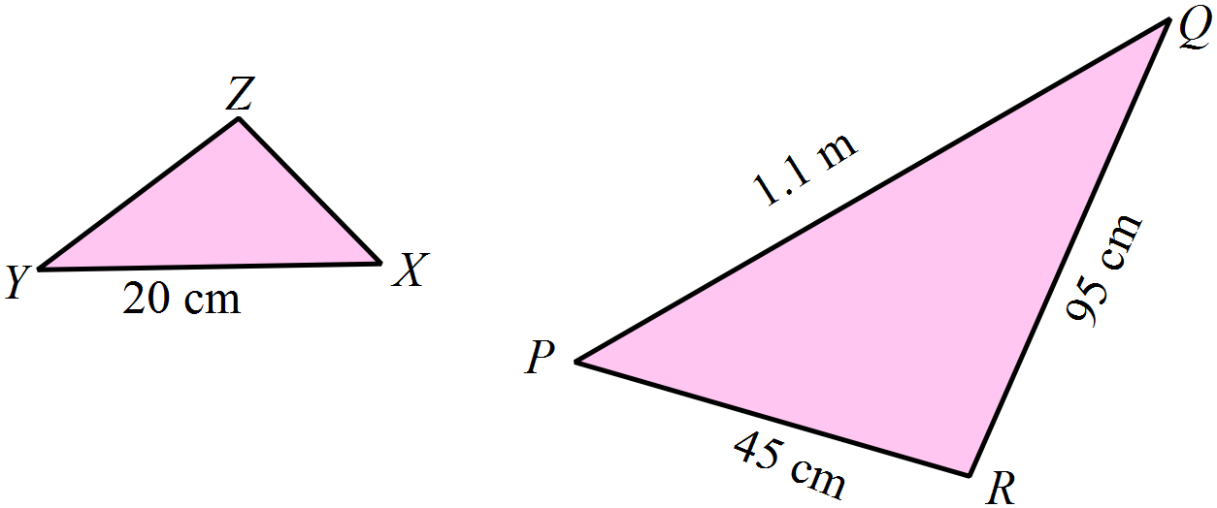
A. 2.25
B. 4.75
C. 5.25
D. 5.5

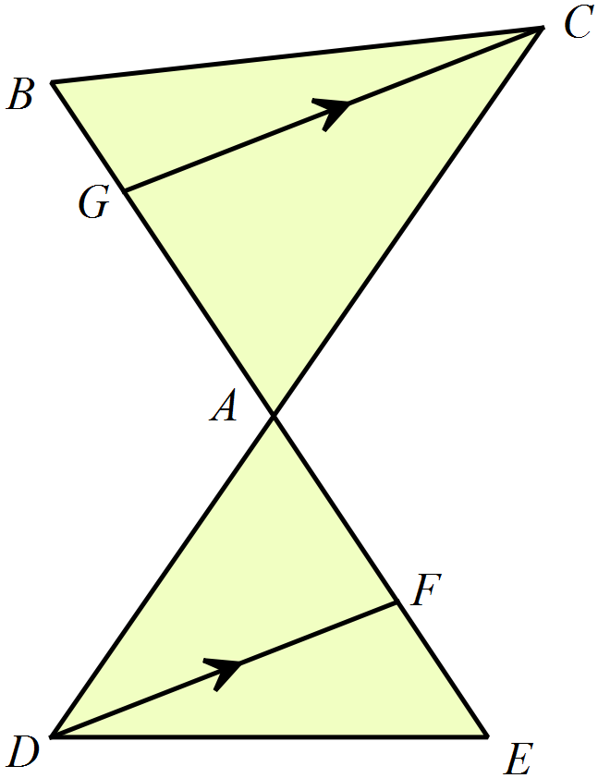In the diagram BE intersects DC at A.
GC || DF.

Which statement names a pair of similar triangles?

A. 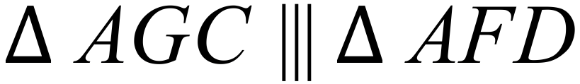
B. 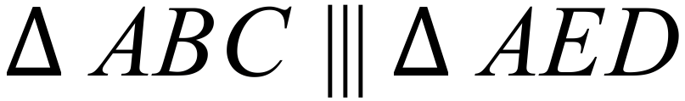
C. 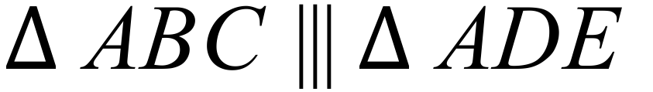
D. 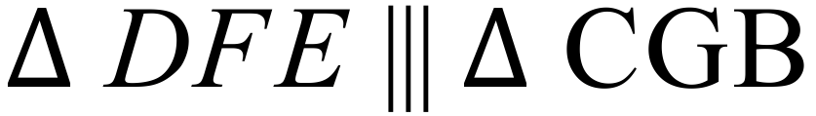
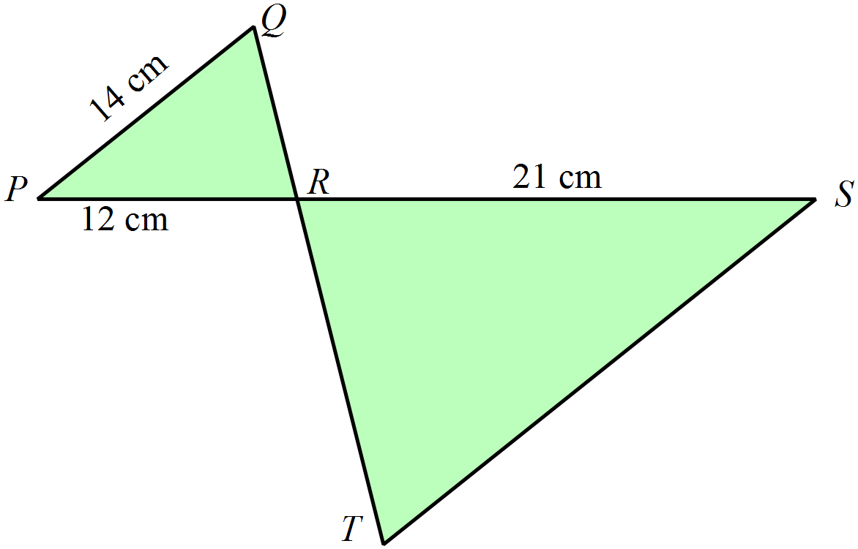In the diagram 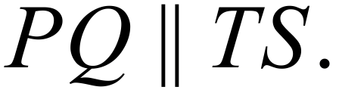

What is the length of TS?
NOT TO
SCALE

A. 8.0 cm
B. 18.0 cm
C. 24.5 cm
D. 27.5 cm

Year 9 | Enlargement & Similarity | Calculator Allowed
Year 9 | Enlargement & Similarity | Name___________________
Section 3 Longer Answer Section
Write all working and answers in the spaces provided on this test paper.
YOU WILL NEED A RULER.

 |  | Marks
1. | Enlarge the triangle BCD with the centre of the enlargement at A, and a scale factor of 4.  Label the image B’C’D’.  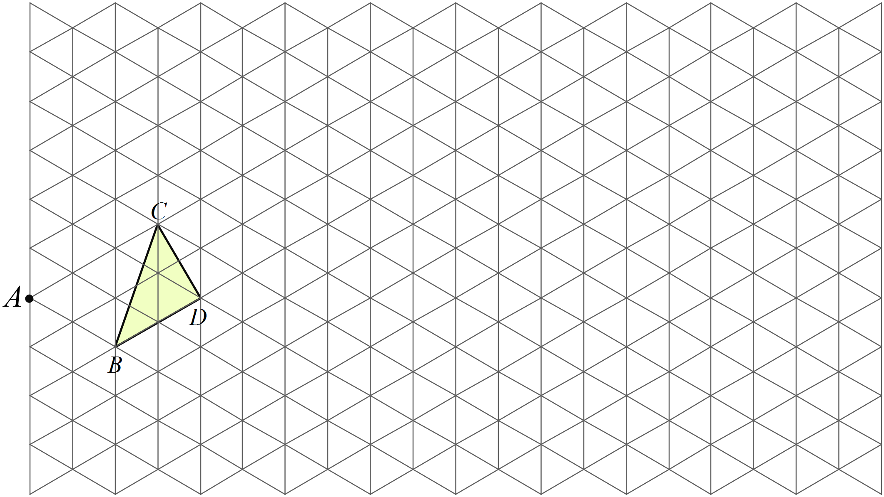 | 3

2. | 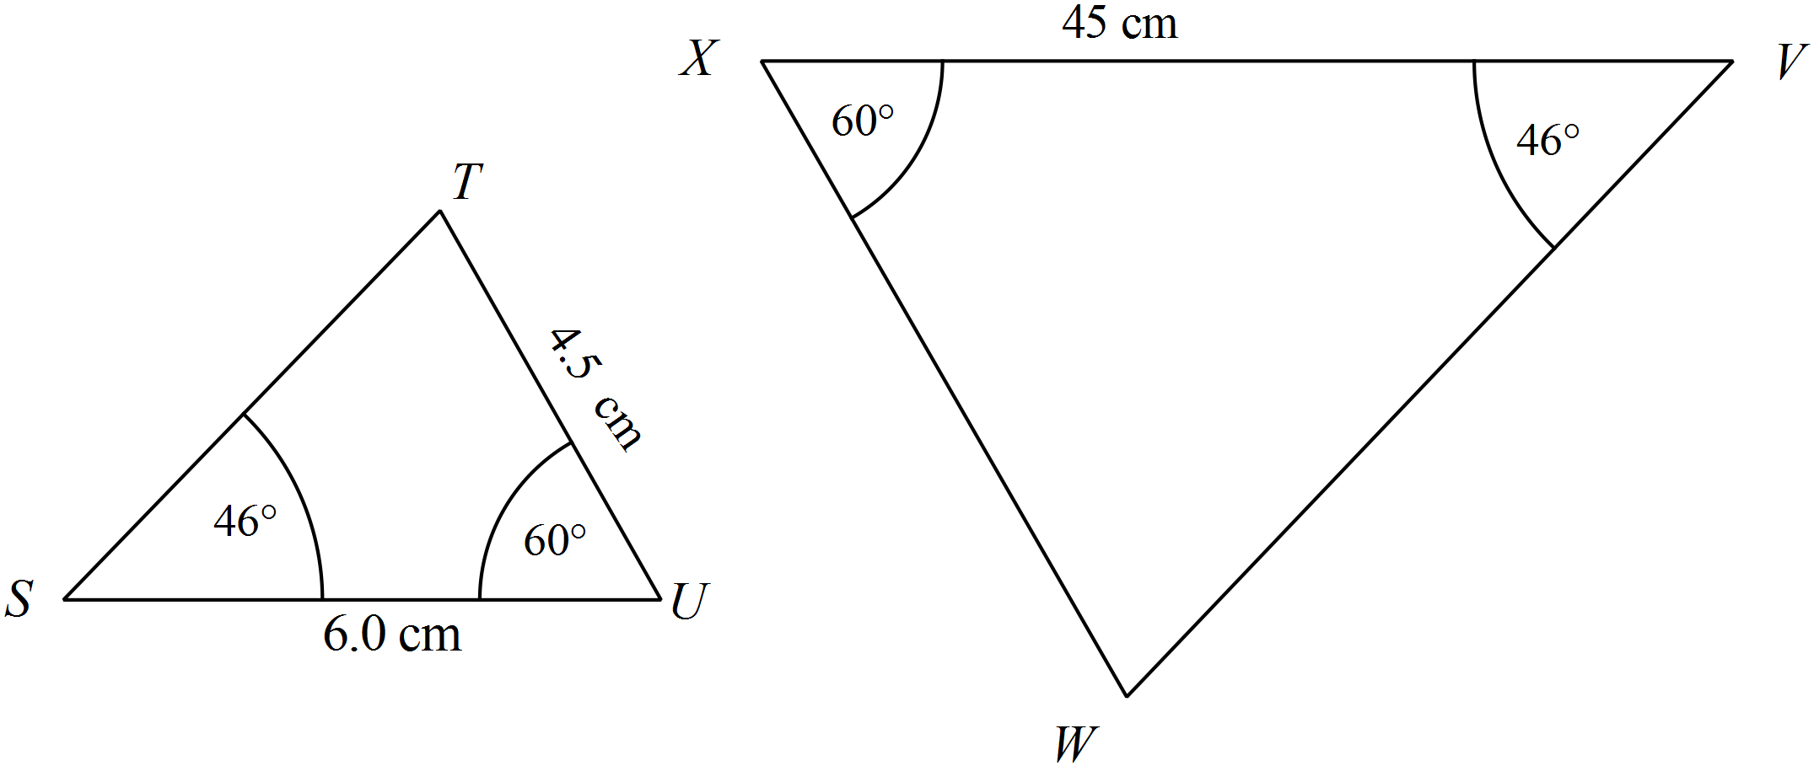  NOT TO  SCALE
 | a) Explain why 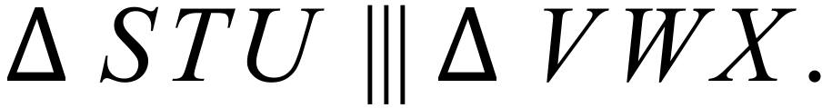  …………………………………………………………………………………………………………………………………………………  ………………………………………………………………………………………………………………………………………………… | 1
 | b) What is the ratio of the corresponding sides?  …………………………………………………………………………………………………………………………………………………  ………………………………………………………………………………………………………………………………………………… | 1
 | c) Find the length of WX.  ………………………………………………………………………………………………………………………………………………….  …………………………………………………………………………………………………………………………………………………  …………………………………………………………………………………………………………………………………………………. | 2
3. | Using the grid provided, or otherwise, draw the image of quadrilateral ABCD after an enlargement with scale factor 2.5 with centre C.  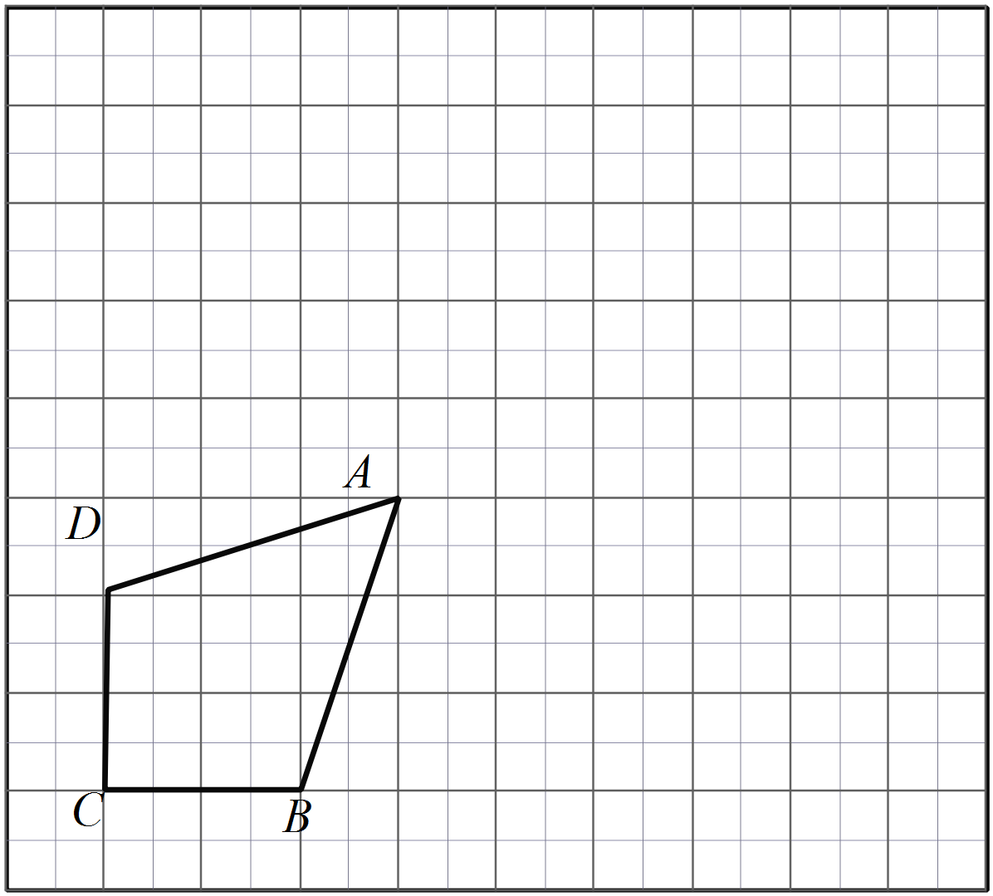 | 3
 | b) The perimeter of the original quadrilateral is 104 mm.  What is the perimeter of the enlarged quadrilateral?  ……………………………………………………………………………………………….  ………………………………………………………………………………………………. | 1
 | c) The area of the original quadrilateral is 6 cm².  What is the area of the enlarged quadrilateral?  ……………………………………………………………………………………………….  ………………………………………………………………………………………………. | 1
4. | 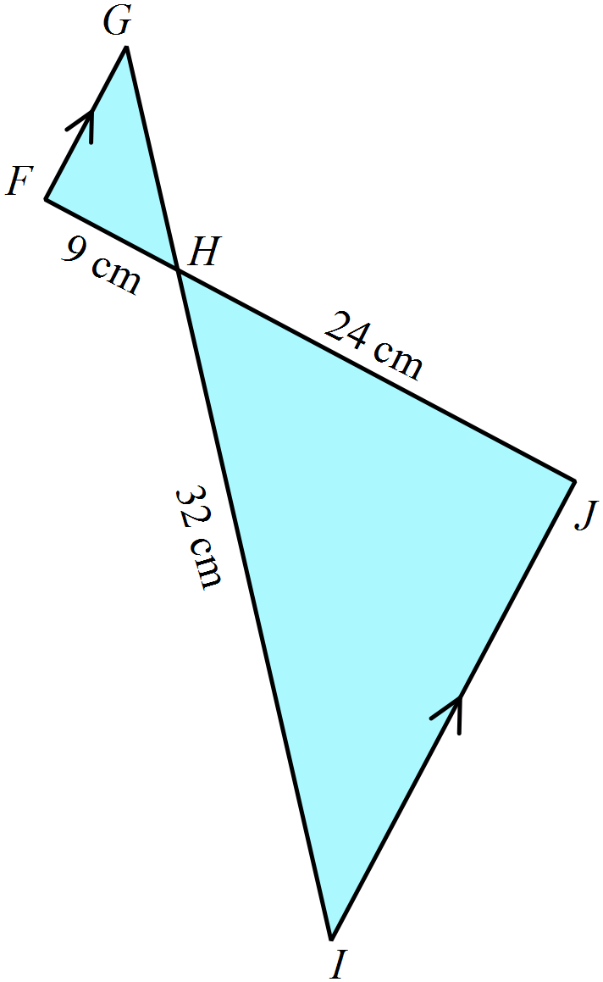(a) Prove that 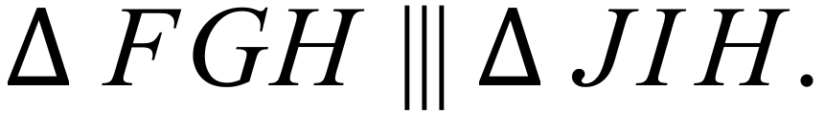  ………………………………………………  ………………………………………………  ……………………………………………....  ………………………………………………  ………………………………………………. | 2
 | (b) Find the length of GH.  ………………………………………………  ………………………………………………  ………………………………………………. | 2
5. | 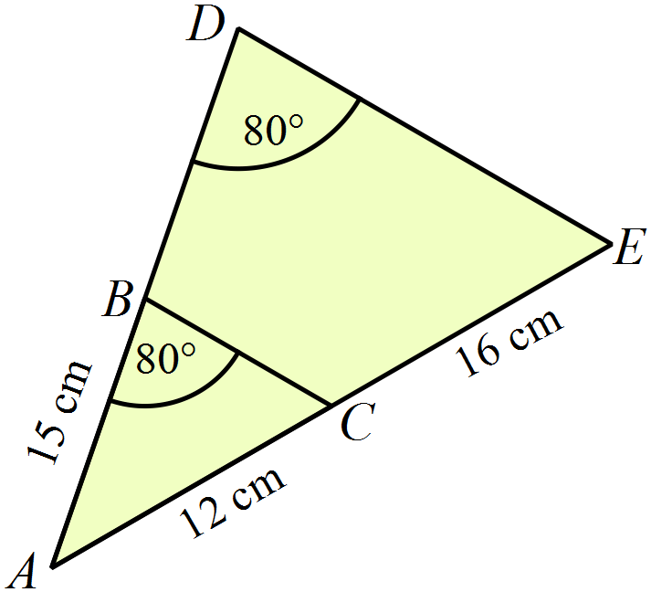(a) Prove that 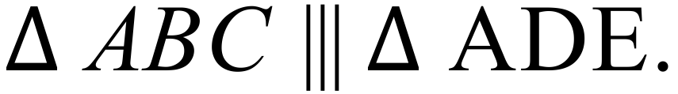  ………………………………………………  ………………………………………………  ……………………………………………....  ………………………………………………  NOT TO  SCALE  ………………………………………………. | 2
 | (b) Find the length of BD.  ……………………………………………………………………………………..  …………………………………………………………………………………….. | 2

Multiple Choice Answer Sheet
Enlargement & Similarity
Name _____________________________________________
Completely fill the response oval representing the most correct answer.

1. A B C D
2. A B C D
3. A B C D
4. A B C D
5. A B C D
6. A B C D
7. A B C D
8. A B C D
9. A B C D
10. A B C D
11. A B C D
12. A B C D
13. A B C D
14. A B C D
15. A B C D
Year 9 |  | Enlargement & Similarity | Non Calculator
Section 1 Short Answer Section
ANSWERS
No. | WORKING |  | ANSWER
 | It would have sides which are  and the angles would be unchanged at 60º. |  | Sides 20 cm  Angles all 60º
 | 6cm enlarges to 18 cm, so enlargement factor = 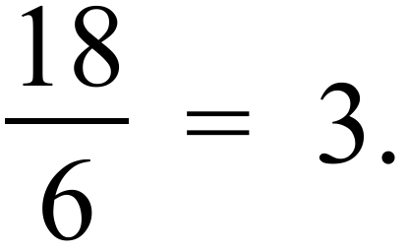 |  | 3
 | 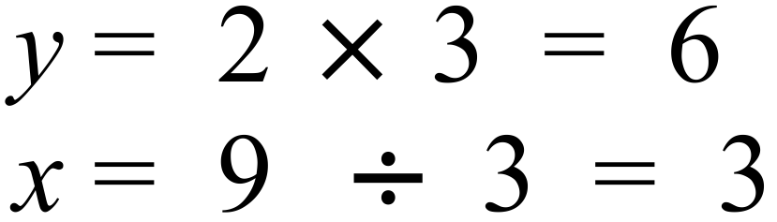 |  | 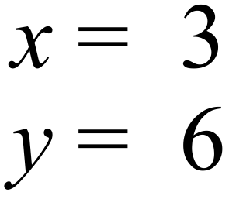
 | Since corresponding angles are equal, the angle equal to 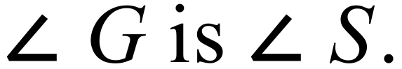 |  | 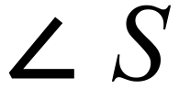
 | The sides if the smaller triangle measure 1 cm, 1.5 cm and 2 cm, and the larger are 3 cm, 4.5 cm and 6 cm, so the scale factor is 3. 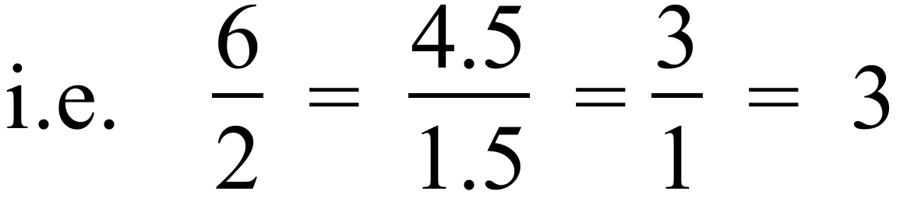 |  | 3
 | CB correspond to FE, so |  | 15 cm
 | Since squares have all sides the same any square will have all sides in the same ratio to another square, similarly as all squares have all angles right angles, the corresponding angles of all squares will be equal, so he is correct. |  | He is correct, see explanation.
 | The scale factor = 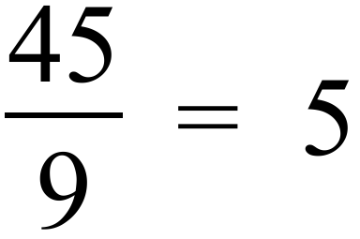  A photo measuring 20 cm across would be enlarged to 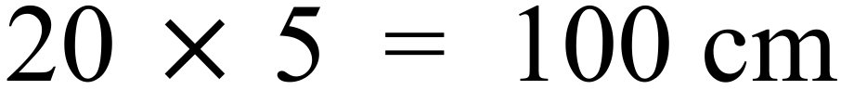 |  | 100 cm or 1 metre
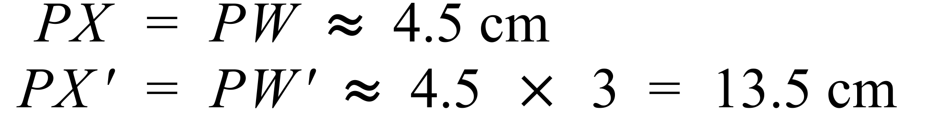
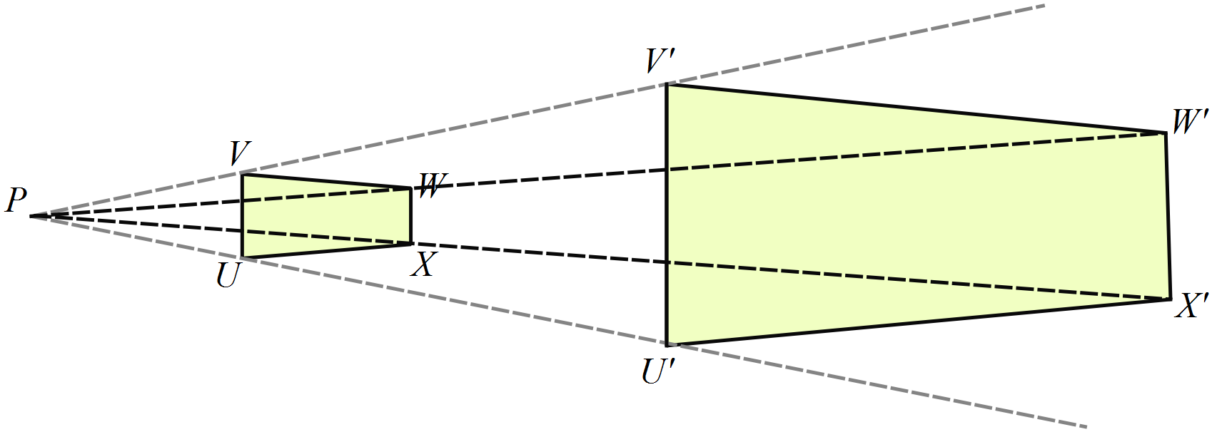

 | FG =3 cm enlarges to F’G’=12 cm,  so enlargement factor = 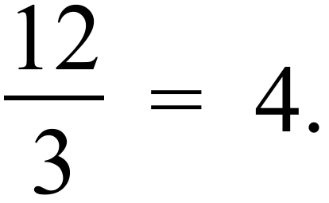  EG =5 cm, so |  | 20 cm
 | The sides of EFG are 2 cm, 3 cm and 4.4 cm, which correspond to 6 cm, 9 cm and 13.2 cm.  So the scale factor is 3. 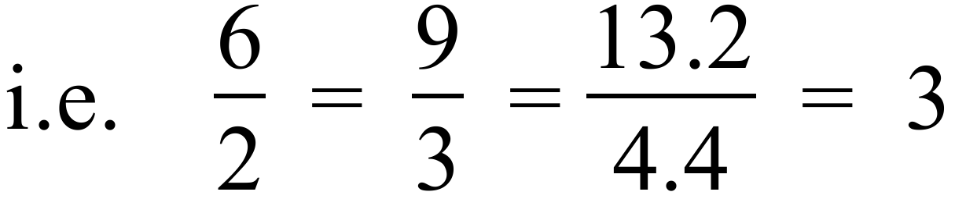 |  | 3
 | 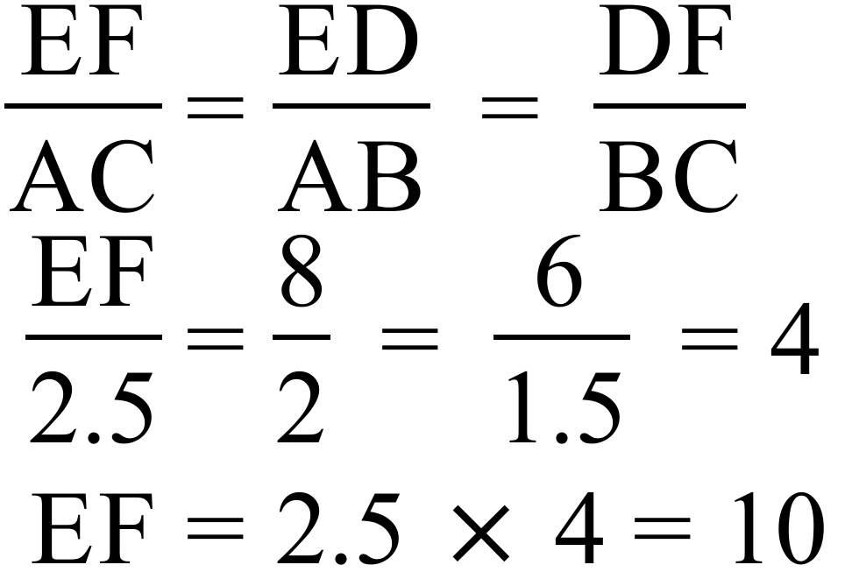 |  | EF = 10 cm
 | The corresponding angles are equal,  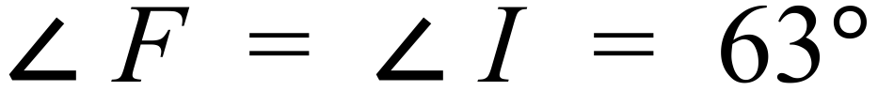, and 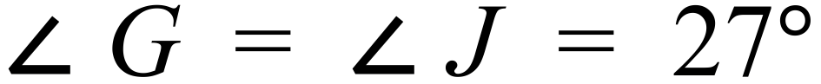 |  | The triangles are similar because the corresponding angles are equal.
 | If shadow is s then 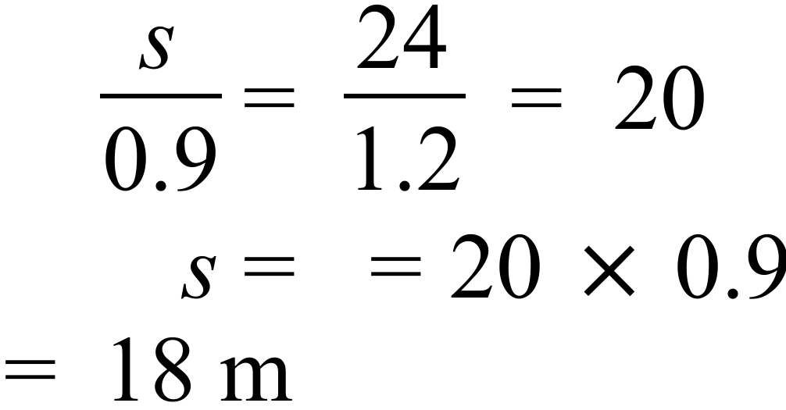 |  | 18 m
 | 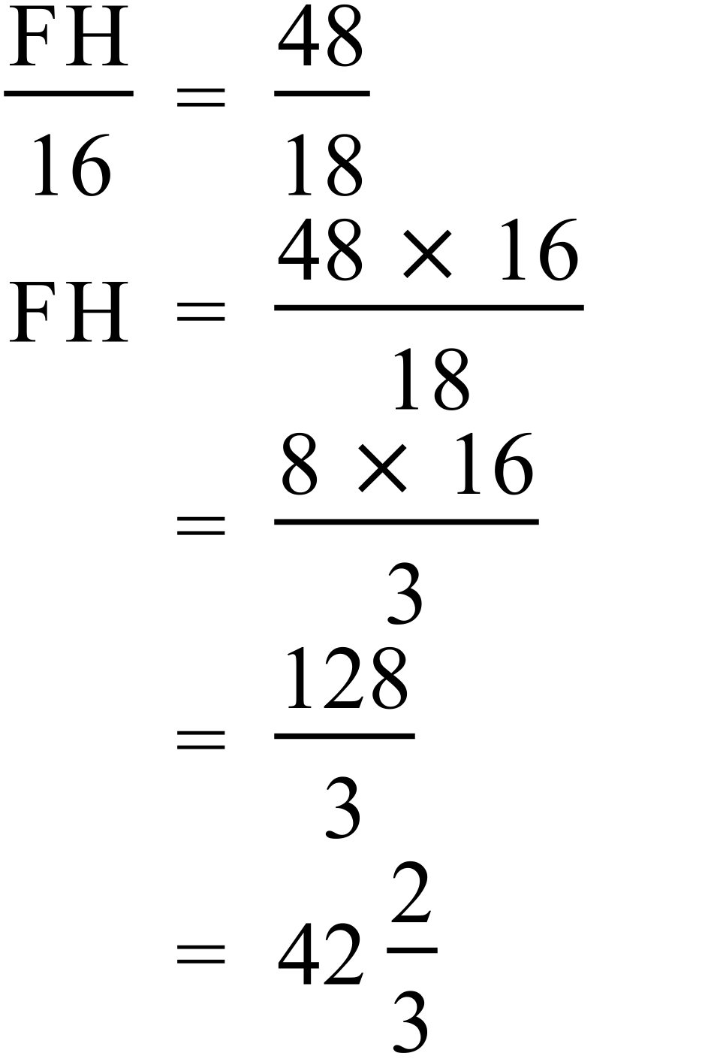 |  | 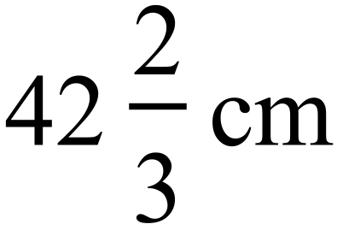

Year 9 |  | Enlargement & Similarity | Calculator Allowed
Section 2 Multiple Choice Section
ANSWERS
No. | WORKING |  |  | ANSWER
 | 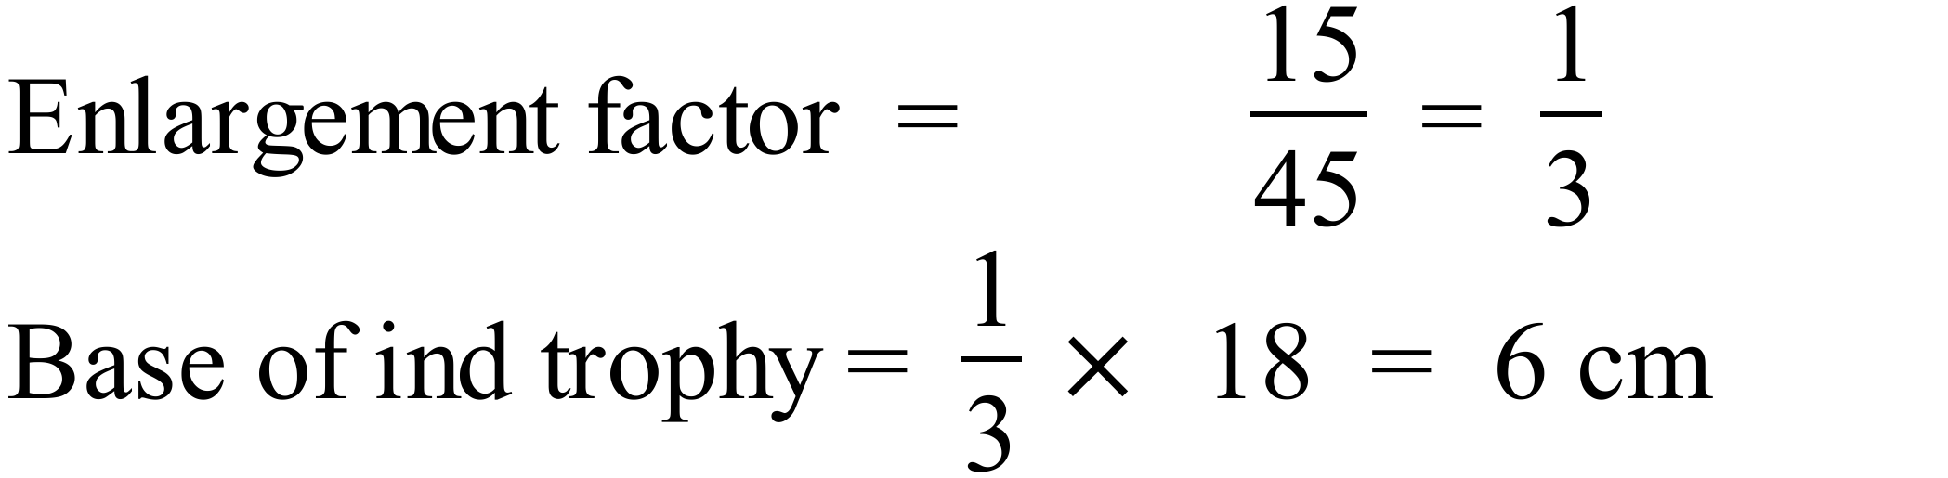 |  |  | B
 | 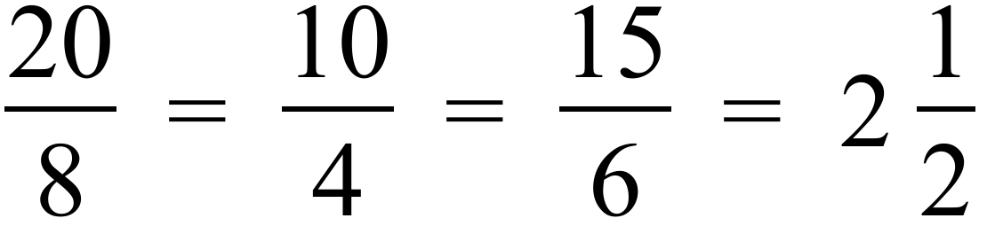 |  |  | C
 | Original sides are 18 cm, 18 cm and 15 cm, so new sides are  18 × 3 cm, 18 × 3 cm and 15 × 3 cm = 54 cm, 54 cm, and 45 cm |  |  | D
 | When compared in the same orientation angle Y is equal to angle J.  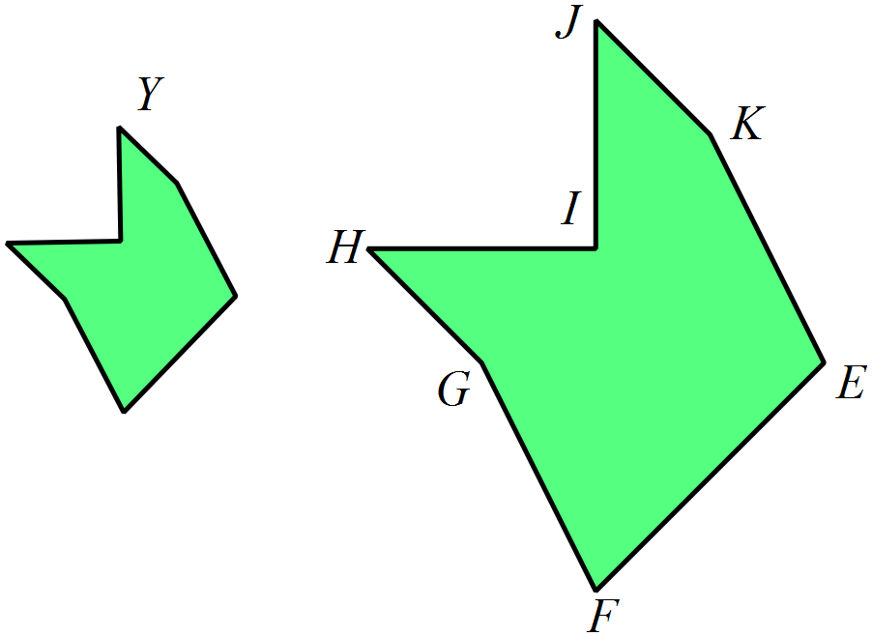 |  |  | D
 | In a pair of similar triangles the corresponding angles are equal and the corresponding sides are in the same ratio.  Words are (in order) angles, sides |  |  | A
 | Since one angle is equal and shapes are parallelograms, all corresponding angles are equal.  So the ratio of sides needs to be the same ratio of shorter to longer in PQRS is 9 : 18 = 1: 2  Only one with same ratio is A where 6 : 12 = 1 : 2. |  |  | A
 | 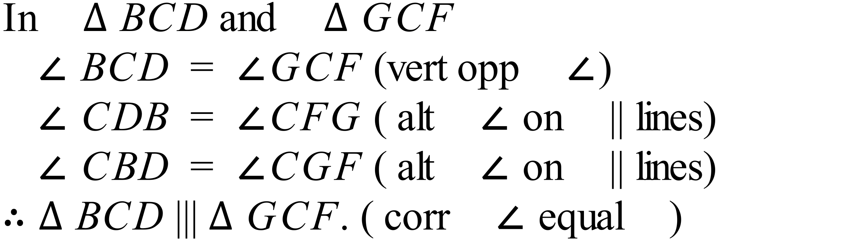 |  |  | C
 | All equilateral triangles are similar since they have all angles 60º which when enlarged remain the same, and since all sides are equal, the corresponding sides are always in the same ratio. |  |  | B
 | Using ratios of corresponding dimensions  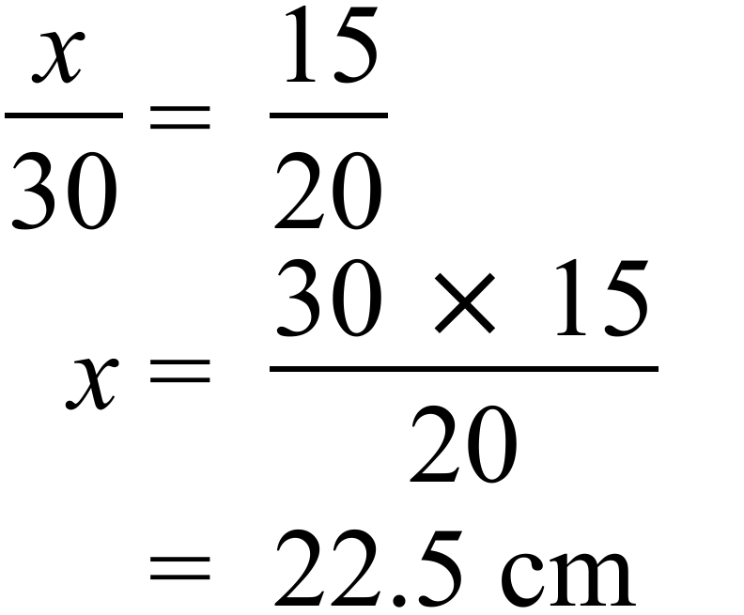 |  |  | B
 | Width as measured = 90 mm.  Width of actual building = |  |  | B
 | 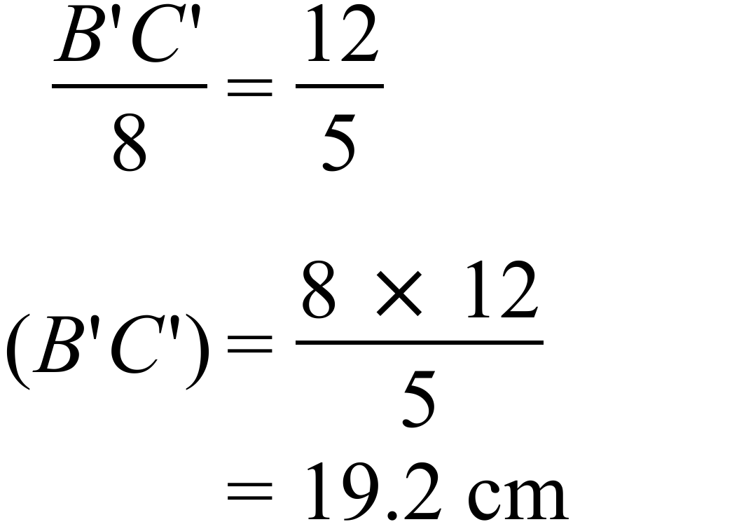 |  |  | C
 | The two sides given are in a ratio 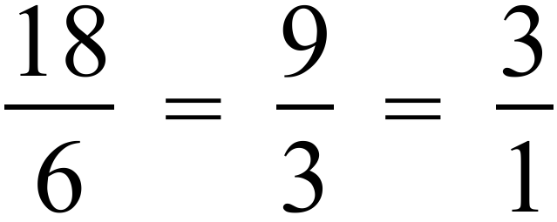 so two sides in the same ratio.  The angles between them are a pair of vertically opposite angles, so reason is : Two corresponding sides of the triangles are in proportion and the included angle is equal |  |  | D
 | The sides XY and PQ are corresponding and have measurements.  So enlargement factor = 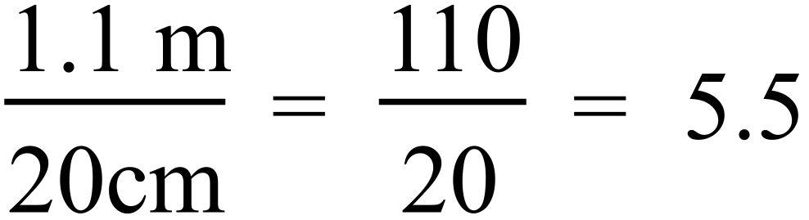 |  |  | D
 | 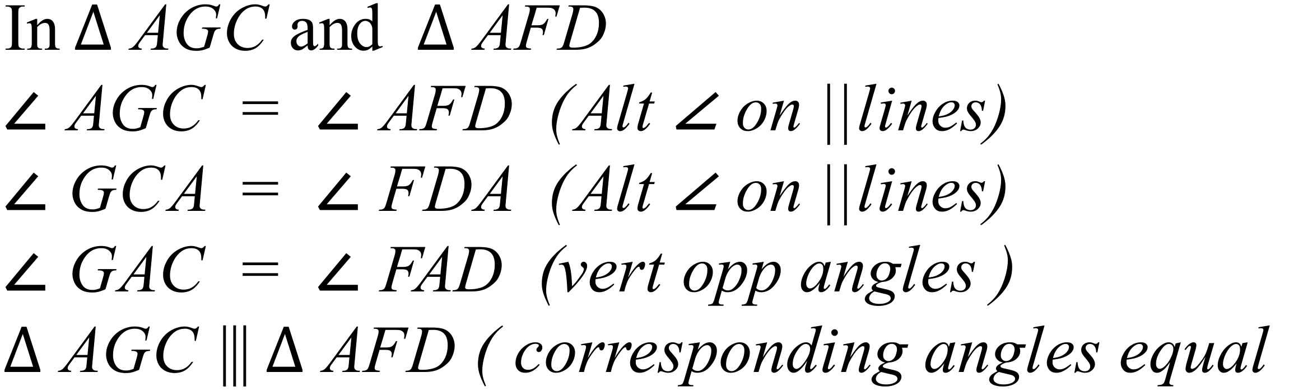 |  |  | A
 | 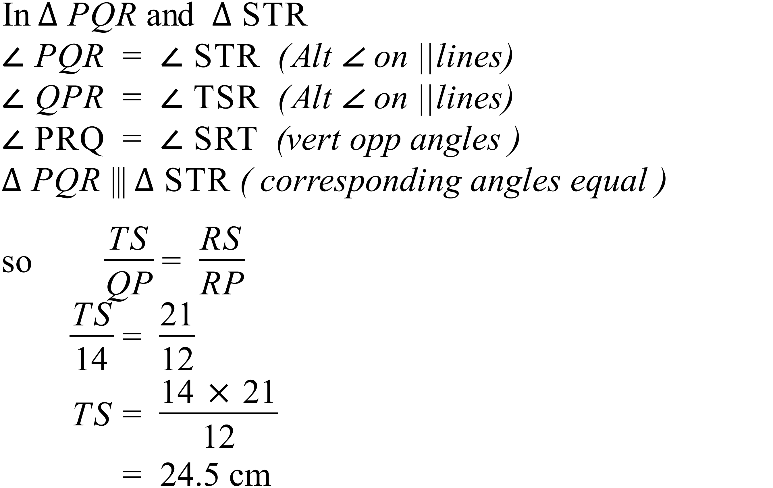 |  |  | C

Multiple Choice Answer Sheet
Enlargement & Similarity
Name _______ANSWERS_______________________________
Completely fill the response oval representing the most correct answer.

1. A B C D
2. A B C D
3. A B C D
4. A B C D
5. A B C D
6. A B C D
7. A B C D
8. A B C D
9. A B C D
10. A B C D
11. A B C D
12. A B C D
13. A B C D
14. A B C D
15. A B C D
Year 9 |  | Enlargement & Similarity | Calculator Allowed
Section 3 Longer Answer Section
ANSWERS
 |  |  |  | Marks
1. | 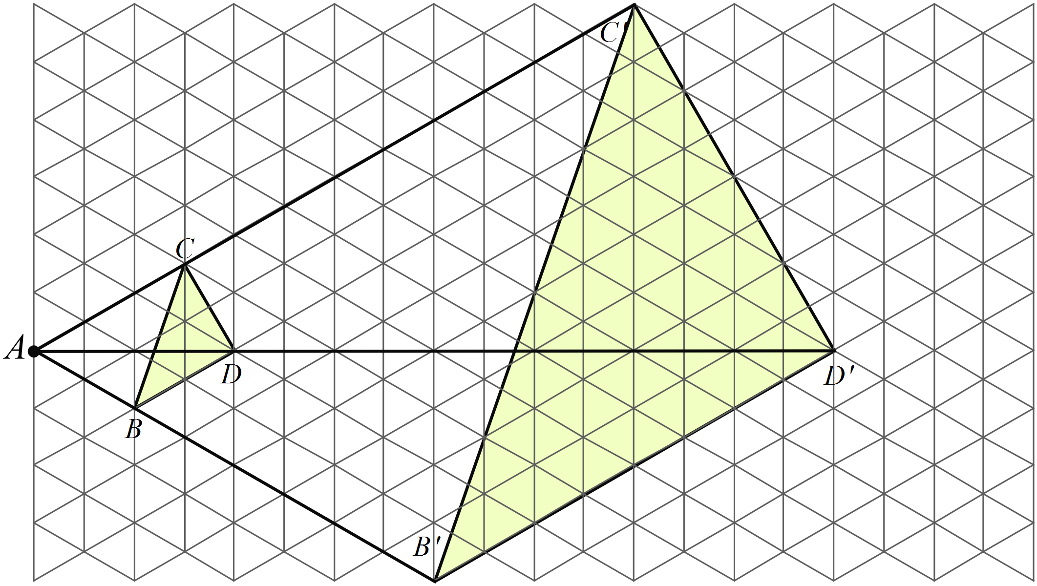 |  |  | 3 marks  2 marks for correct triangle with evidence of construction.  1 mark for labelling image
2. | (a) 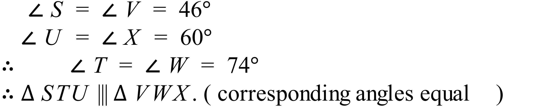 |  |  | Formal proof not required for 1 mark, just an explanation that corresponding angles are equal
 | (b) |  |  | Ratio in any format for 1 mark
 | (c) 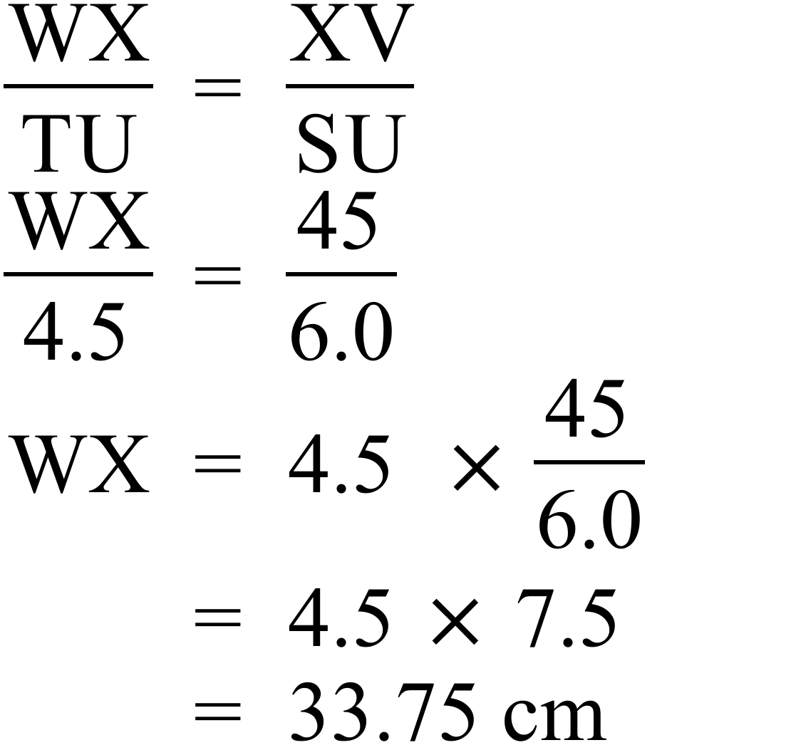 |  |  | 2 marks for correct answer.  1 mark for an attempt at the solution that includes equal ratios
3. | 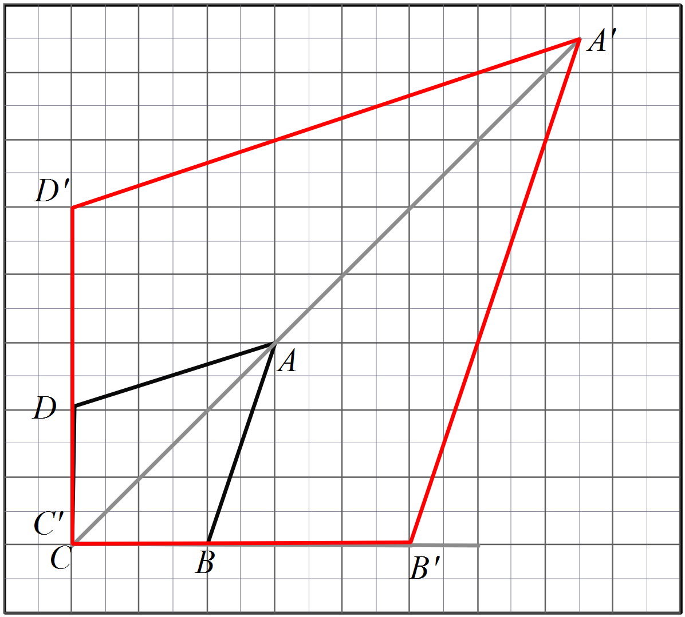 (a) |  |  | 2 for sketch
 | (b) Perimeter of image is 2.5 times that of the original |  |  | 1 for answer
 | (c) Area of image is 2.5² times that of the original ( 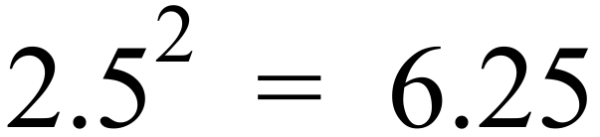 )  Area = 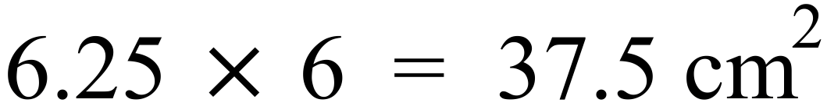 |  |  | 1 for answer
4. | (a)  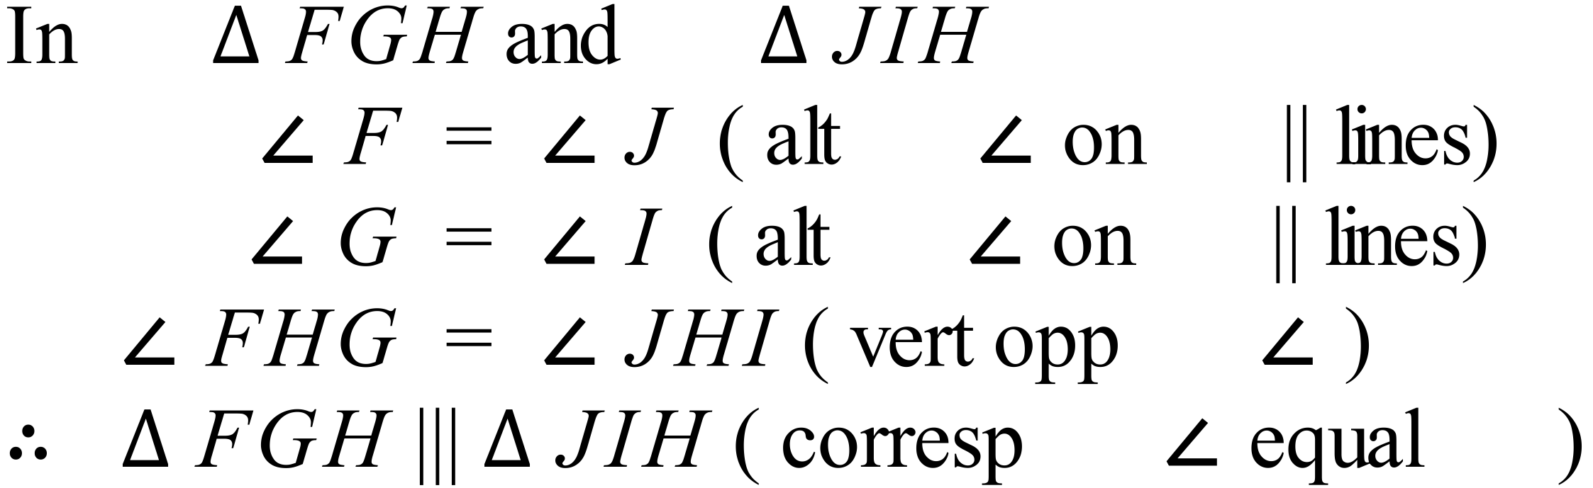 |  |  | 2 marks for an answer which includes at least 2 pairs of equal angles and a conclusion.  1 mark for a partial answer or minor error
 | (b)  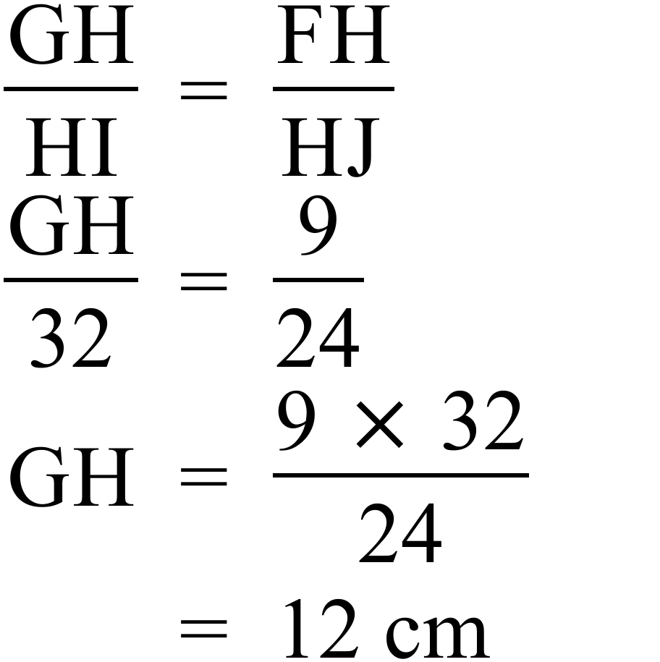 |  |  | 2 marks for an answer which includes required ratio and correct answer.  1 mark for a partial answer or minor error
5. | (a)  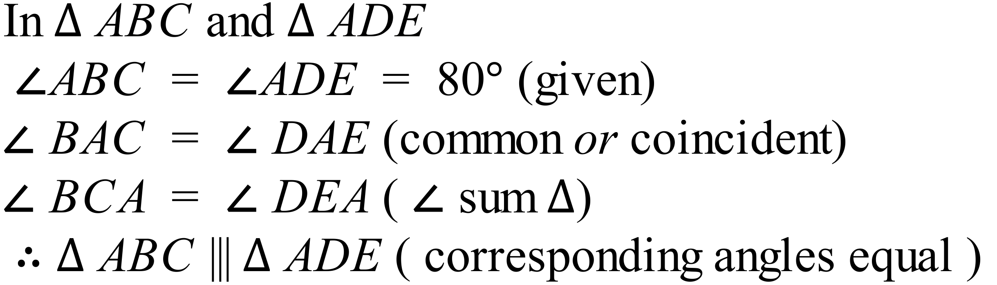 |  |  | 2 marks for an answer which includes at least 2 pairs of equal angles and a conclusion.  1 mark for a partial answer or minor error
 | (b)  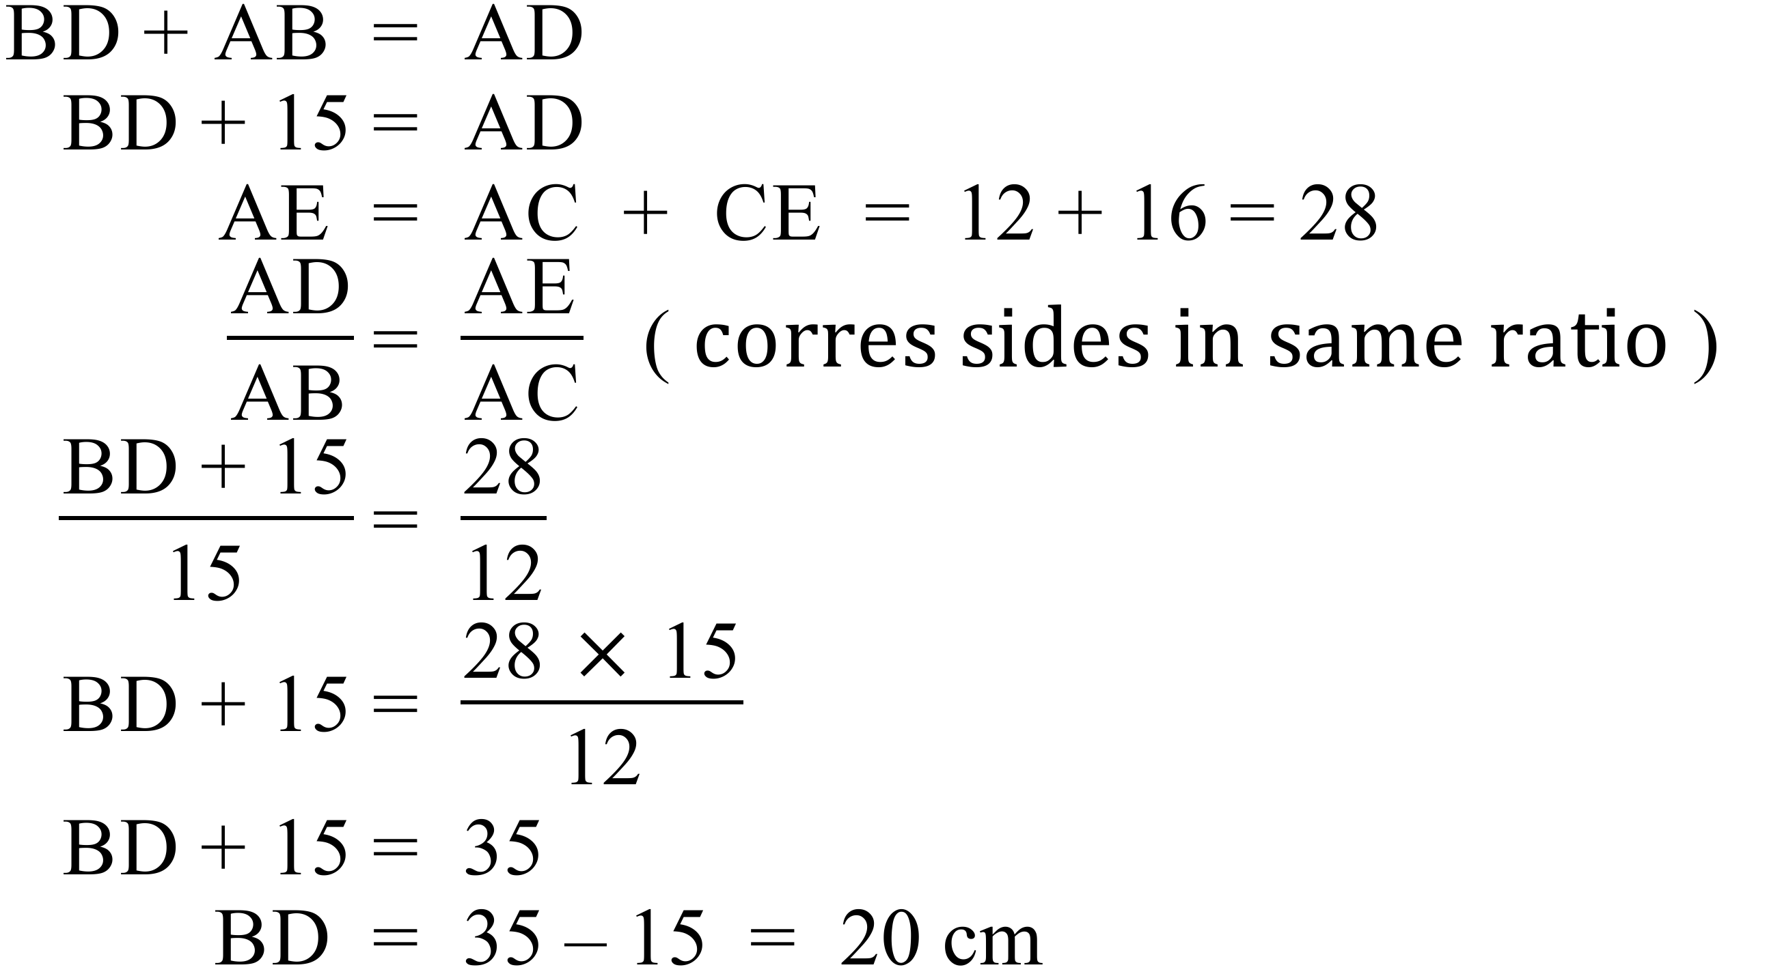 |  |  | 2 marks for an answer which includes required ratio and correct answer.  1 mark for a partial answer or minor error

